A Methodology for Validating the Thematic Quality of Decametric Spatial Resolution Leaf Area Index and fAPAR Products using In-Situ Fiducial Reference Measurements

May 10, 2026

Fernandes, Brown, Nickeson, Niro, Tang + all others in alphabetical order

Document Change Record
Iss. | Rev. | Date | Reason | Comments
0 | 0 | October 24, 2025 | Initial draft | Draft outline for CEOS review
0 | 1 | November 13, 2025 | CEOS draft | Draft outline for external review
0 | 2 | <ay 6, 2026 | Major revision after initial external review. | Scope reduced and methods simplified.

Abstract

Context

Leaf Area Index (LAI) and the Fraction of Absorbed Photosynthetically Active Radiation (FAPAR) are biophysical indicators that, respectively, quantify terrestrial vegetation density and potential gross primary productivity.

LAI and FAPAR products at spatial resolution <=250m and temporal resolution <=10d are required by the United National Global Climate Observing System (GCOS). These requirements can be generally satisfied using algorithms applied to decametric resolution optical and radar satellite data fundamental data records.

Conformity to thematic quality requirements by GCOS and other users must also be addressed through validation. . The Committee of Earth Observation systems requires validation using matchups that are globally representative and ideally using in-situ fiducial reference measurements.

Survey
Current validation methods quantify thematic quality rely on estimates derived from limited matchups of product and reference measurements that are not global representative of product measurement conditions. Matchups using reference estimates, derived by combing in-situ reference measurements, have been used to improve representativeness but the additional uncertainty of matchups on validation estimates is generally ignored. The majority of studies report validation results aggregated over all matchups rather than, as required by GCOS and CEOS, conditional on the measured LAI or FAPAR.

This Study
- A method for quantifying the uncertainty, apparent bias and apparent accuracy of decametric resolution LAI and FAPAR satellite products with synoptic extent is presented that:
- Estimates the probability validation statistics are representative of product measurements.
- Quantifies the impact of addititional uncertainty when using fiducial reference estimates on validation statistics.
- Determines the conformity of product measurements to user requirements

Findings

- Representativeness:
- Impact of FRE:
- Conformity:

Introduction

Leaf area index (LAI) and the fraction of absorbed photosynthetically active radiation (FAPAR) (hereafter LAI/FAPAR) measure, respectively, the density and potential gross primary productivity of terrestrial vegetation (Watson, 1947; Monteith 1972; WMO, 2022) (bold terms are defined in Appendix 1). LAI/FAPAR are essential agriculture, biodiversity and climate variables required for systematic monitoring of vegetation status and trends (Navarro et al., 2017; GEOGLAM 2022; United Nations, 2022; FAO, 2025; WMO, 2025).

LAI/FAPAR thematic data products are routinely generated for synoptic and global extents using fundamental data records (FDRs) from satellite optical imagers, synthetic aperture radar (SAR) imagers and light detection and ranging (LIDAR) instruments

(Fernandes et al., 2014; Campos-Taberner et al., 2017; CEOS, 2018; Fang et al., 2019; Dubayah et al., 2020).

The Committee on Earth Observation Satellites (CEOS) has been tasked by the United Nations Global Climate Observing System (GCOS) with developing and publishing methods for validating LAI/FAPAR products (CEOS, 2018). CEOS endorses the Quality Assurance Framework for Earth Observation (QA4EO) framework (https://qa4eo.org/documents/#guidelines) that defines validation as "Verification, where the specified requirements are adequate for an intended use" (JGCM, 2021) . This definition implies that validation entails not just quantifying product quality but also testing for conformity with specified user requirements.

GCOS specifies temporal, spatial, and thematic requirements for estimating LAI and FAPAR (i.e., the measurands) at threshold (minimum usability requirements) , breakthrough (performance sufficient for specific applications) , and goal levels (performance that meets all foreseeable user needs) (Table 1; WMO, 2025).

Table 1. GCOS threshold, breakthrough, and goal user requirements for LAI/FAPAR products.
Requirement | Units | LAI |  |  | FAPAR
 |  | threshold | breakthrough | goal | threshold | breakthrough | goal
Horizontal  Resolution | m | 250 | 100 | 10 | 250 | 250 | 10
Temporal  Resolution | d | 10 | 10 | 1 | 10 | 10 | 1
Timeliness | d | 10 | 5 | 1 | 10 | 5 | 1
Relative Standard Uncertainty | % | 10 | 10 | 5 | 5 | 5 | 2.5
Minimum Standard Uncertainty | 1 | 0.05 | 0.05 | 0.025 | 0.025 | 0.025 | 0.0125
Stability | %/year | 0.6 | 0.6 | 0.3 | 0.3 | 0.3 | 0.1

Methods for validating temporal resolution and horizontal resolution requirements are beyond the scope of this study. Temporal resolution requirements can be validated by assessing the frequency of LAI/FAPAR estimates for a given mapping unit (e.g., Fuster et al., 2020; Verger et al., 2025). Horizontal resolution requirements are generally met by products derived from decametric-resolution FDRs (Gascon et al., 2017; Gaudel et al., 2017; Chaote et al., 2023; Schnider et al., 2023). Timeliness depends on mission-specific data acquisition and processing infrastructure and must therefore be validated on a case-by-case basis through system-level testing, which is also beyond the scope of this study.

This study presents methods for validating thematic quality requirements for relative standard uncertainty, minimum standard uncertainty and stability using Joint Committee for Guides in Metrology definitions adopted by QA4EO (JGCM, 2021). Uncertainty is defined as a “parameter characterizing the dispersion of the values being attributed to a measurand” after correction for measurement bias. Bias is defined as “an estimate of systematic error”; where error is defined as” the measured value minus a reference value”. Standard uncertainty corresponds to the use of standard deviation of attributed values to characterize their dispersion, and relative standard uncertainty is the standard uncertainty divided by the estimated product measurement from these values. Stability is defined by GCOS as the change in bias per decade (GCOS, 2025).

GCOS requirements do not include accuracy, defined as the “closeness of agreement between a measurement result and a reference value of a measurand.” However, many observing systems specify requirements for relative standard accuracy, defined as the standard deviation of differences between measurement and reference values divided by the measurement value (Malenovský et al., 2012; Defourny et al., 2019; Chabrillat et al., 2022; Stavros et al., 2023). Relative standard accuracy requirements can be validated when the reference value is a conventional value, that is, a value established by agreement and assumed to represent the true value of the measurand (e.g., for non-vegetated surfaces). In other cases, accuracy cannot be quantified without prior assumptions because the uncertainty of the reference value, itself derived from measurements, is unknown. This limitation has led to the use of the adjective “apparent” to describe errors and accuracy estimates derived from measured reference values (Widlowski, 2015). Neither QA4EO nor JGCM guidelines use the adjective “apparent”. Rather than introducing additional terms, it is sufficient to state that accuracy requirements can be validated using statistics derived from measured reference values together with a coverage interval, defined as an interval containing the validated quantity (e.g., accuracy) with a stated probability based on the information available.

The CEOS Land Product Validation subgroup defines a four-stage hierarchy for validating the thematic quality of satellite-derived Earth observation products (restated in Table 2 using QA4EO terminology). This study addresses methods for Stage 3 and Stage 4 validation of decametric-resolution LAI/FAPAR products. Both stages require validation across many locations (>30 for Stage 3; globally representative conditions for Stage 4) and multiple time periods but Stage 4 requires ongoing validation using fiducial reference measurements (FRM). Fiducial reference measurements are defined as “a suite of independent, fully characterised, and traceable sub-orbital measurements that follow the guidelines outlined by the GEO/CEOS Quality Assurance framework for Earth Observation (QA4EO) and have value for space-based observations.” ( QA4EO website: http://qa4eo.org/; CEOS, 2025). To our knowledge, no Stage 4 validation studies currently exist for decametric LAI/FAPAR products.

Most Stage 3 studies follow current good practice (e.g., Richter et al., xx; Fernandes et al., xx; Fang et al. xx) by reporting population statistics of observed errors, defined as a measured value minus a reference value, stratified by distinct land cover groups. These statistics represent expected errors for a population corresponding to similar intermediate precision conditions of measurement (conditions that correspond to the same sources of error, here simply ‘conditions’) of reference a class rather than the measurement condition of any individual product estimate as required by GCOS. Population statistics can also be misleading for testing for differences in product thematic quality as a function of FDR or algorithm unless they reference sample is held constant.
For example, the reported accuracy of Sentinel-2 LAI products generated with the Simplified Level 2 Prototype Processor (SL2P) algorithm for 42 deciduous broadleaf forest (DBF) AUs within the US National Ecological Observatory Network (NEON) changed substantially as the validation sample expanded: RMSE estimates were initially 1.18 ± 0.03 for 203 matchups (Fernandes et al., 2023), decreased to 0.94 ± xx for 500 matchups (Fernandes et al., 2024), and later increased to 1.43 ± xx when the sample size increased further (Brown et al., 2025)

Table 2. CEOS Validation Stages.
Level | Definition
0 | No validation. Product thematic quality has not been assessed. Product considered beta.
1 | Product thematic quality is validated with respect to user requirements for a small (typically < 30) set of locations and time periods by comparison with in situ or other suitable reference data.
2 | Product thematic quality is validated with respect to user requirements over a significant (typically > 30) set of locations and time periods by comparison with reference in situ or other suitable reference data.  Spatial and temporal consistency of the product, and its consistency with similar products, has been evaluated over globally representative locations and time periods.  Results are published in the peer-reviewed literature.
3 | Product thematic quality is validated with respect to user requirements over a significant (typically > 30) set of locations and time periods representing global conditions by comparison with reference in situ or other suitable reference data. Validation procedures follow community-agreed-upon good practices.  Spatial and temporal consistency of the product, and its consistency with similar products, has been evaluated over globally representative locations and time periods.  Results are published in the peer-reviewed literature.
4 | Validation results for stage 3 are systematically updated when new product versions are released or as the interannual time series expands.  When appropriate for the product, product thematic quality is validated with respect to user requirements using fiducial reference measurements over a global network of sites and time periods (if available).

Current CEOS good practice improves the representativeness of thematic quality statistics by conditioning them on the reference measurement, thereby reducing the range of conditions represented within each statistic (Fernandes et al., 2014). Both histogram-based (Fuster et al., xx) and weighted polynomial regression estimators (Fernandes et al., xx) have been applied for this purpose. The latter provides the additional benefit of producing unbiased statistics while accounting for FRM uncertainty. Both approaches reduce the sensitivity of thematic quality statistics to the reference sample, enabling comparisons between products from different algorithms and input FDRs (Fernandes et al., xx). However, quality statistics conditioned only on the reference measurement are not well suited to GCOS LAI/FAPAR validation because it quantifies only the expected value of quality metrics for a given reference value, rather than the conformity of individual product estimates with user requirements. In addition, they assume that conditions are fully characterized by the reference measurement, whereas other factors—including canopy clumping, woody cover, canopy optical properties, and FDR measurement error—can also influence product estimates ().

Camacho et al. (2025) evaluated the conformity of hectometric Sentinel-3 FAPAR estimates with mission accuracy requirements by comparing individual product estimates against concident reference measurements derived by spatially aggregating decametric-resolution FAPAR maps calibrated using local FRM. Their approach incorporated both reference measurement uncertainty, through propagation of FRM uncertainty to the reference values, and product uncertainty, using theoretical uncertainty estimates provided by the retrieval algorithm, to define a coverage interval for each comparison. While their study highlighted the importance of incorporating both reference and product uncertainty when validating accuracy requirements, the approach has several limitations as a method for validating decametric LAI/FAPAR products against GCOS requirements within the CEOS framework:
i. CEOS requires uncertainty to be evaluated through comparisons with reference measurements (Type A evaluation of measurement uncertainty), whereas the study relied on producer-provided uncertainty estimates.
ii. Stability was not assessed.
iii. Matchups, defined as coincident product and reference measurements, depended on reference measurements with spatial resolution more than an order of magnitude finer than the product resolution, a requirement that cannot currently be met using only FRMs.
iv. Conformity was assessed only for product measurements coincident with reference values (Stage 3), rather than for arbitrary ongoing product measurements (Stage 4).

The goal of this study is to define and demonstrate a methodology for CEOS Level 4 validation of decametric-resolution LAI/FAPAR products that addresses the limitations of previous studies by answering three research questions:
- How can conformity with user requirements for accuracy, uncertainty, and stability be quantified from available matchups in a manner robust to measurement and matching errors?
- How can conformity tests be compared between algorithms that produce different matchups?
- How can conformity with user requirements for accuracy, uncertainty, and stability be quantified for product estimates without corresponding matchups?
Section 1 presents the theoretical basis of the methodology, building on the experimental design framework of the CEOS Land Cover validation protocol (xx) and QA4EO guidelines. Section 2 describes a dataset representative of a globally applicable LAI/FAPAR algorithm and associated fiducial reference measurements (FRMs). Section 3 applies the proposed framework to validate GCOS requirements, first using observed-error matchups (Stage 3) and then using a globally representative set of product estimates (Stage 4). Section 4 discusses the strengths and limitations of the approach for both the products analyzed here and other LAI/FAPAR products. Conclusions addressing the three research questions are presented in Section 5.

Theory

2.1 User Requirement Specification

A user requirement specification is a document that defines:
- Measurands (y), the particular quantity subject to measurement (e.g. LAI\FAPAR),
- required parameters (x), known quantitative characteristics associated product measurements (y) (e.g. mapping units, the estimated LAI or FAPAR uncertainty, in-situ conditions)
- and tolerance limits, intervals of limiting values that separate intervals of permissible values of the measurand from intervals of non-permissible values.

2.2.1 LAI and FAPAR Measureand

LAI and FAPAR measurands must be defined in the user requirement specification. These definitions will have associated definitional uncertainty— arising from the finite specificity of a measurand definition. GCOS provides global definitions for LAI and FAPAR (Table 1) but these will have varying levels of uncertainty for specific conditions due to natural variability within ecosystems. For example, GCOS does not clearly define the condition “green” with respect to LAI or the adjective “effectively” with respect to FAPAR. To reduce ambiguity, CEOS has published proposed clarifications of the GCOS definitions (Table 3; Fernandes et al., xx, xx). These clarifications identify excluded conditions and highlight known sources of uncertainty for which community consensus on quantification has not yet been achieved. These sources of definitional uncertainty should be explicitly quantified using expert consensus or numerical simulations (Type B uncertainty quantification) and incorporated in conformity tests.

Table 3. GCOS definition of LAI/FAPAR measurands (WMO, 2025) with conditions specified by CEOS (Fernandes et al., 2024a,b)
Measurand | Leaf Area Index | Fraction of Absorbed Photosynthetically  Active Radiation
Abbreviation | LAI | FAPAR
SI Symbol | None | None
SI Units¹ | 1 | 1
Definition | half the total green leaf area per unit horizontal ground area | the fraction of incoming solar radiation in the 400–700 nm spectral range that is absorbed by green elements of plants for photosynthesis
Exclusion Conditions | non vascular organs (miss, bryophytes, green stems). Green leaves below the ground or water surface. | Plants below the ground or water surface.
Unspecified sources of uncertainty. | Definition of “green” | Definition of “green” and “effectively”  Incoming solar radiation field. Adjectives include:  Direct: direct solar illumination  Diffuse: isotropic over lower hemisphere downwelling solar radiation  Ambient: ambient downwelling solar radiation field
¹The System International dimensions of LAI and FAPAR units is “1” and are omitted (Thompson and Taylor, 2008).

2.1.2 Product Parameters

CEOS validation requires conformity testing based on errors observed for matchups y,y over a specified spatial and temporal extent. The product mapping unit (PMU), defined as the spatial and temporal extent associated with a product measurement, must be specified for each observation to enable matchup identification. Current decametric LAI/FAPAR products have a temporal extent can generally be assumed to be instantaneous, while the spatial extent corresponds to the geometric mapping unit of the product (e.g., pixel or polygon).

Products also include parameters describing conditions for a PMU that can support conformity testing. These include acquisition geometry, time, location, theoretical uncertainty estimates based only on the FDR, and gridded climate variables. Such parameters can be used to stratify or group product measurements during conformity analysis. In special cases, for example at FRM sites, in-situ parameter measurements (e.g. climate variables, soils, species, canopy optical and structural properties) may be available.

2.1.3 Tolerance Interval

GCOS requirements include tolerance intervals for horizontal resolution, temporal resolution, uncertainty, and stability, which must be simultaneously satisfied for a measurement to be considered conforming. GCOS does not explicitly define tolerance intervals for accuracy; however, these can be taken as at least equivalent to those for uncertainty, since accuracy includes both random and systematic errors.

GCOS horizontal and temporal resolution intervals define the extent of matchups over which errors between product and reference measurements are quantified. Matchups may include multiple associated product and reference measurements and can contain gaps due to missing FDR observations or invalid retrievals. Although each associated measurement is a sample of matchup conditions its temporal and spatial representativeness may vary. For example, product observations over an agricultural field may include both pre- and post-harvest conditions within the matchup while the reference measurement may correspond to only one of these states. Additionally, the spatial footprint of a measurement may sample regions outside the matchup due to the measurement approach or geolocation errors. Consequently, methods are required to maximize the likelihood that product and reference measurements within a matchup correspond to the same underlying conditions.

2.2 Type of Validation

Measurement uncertainty can be quantified using Type A evaluation, which relies on statistical analysis of series of observations, or (not exclusively) Type B evaluation, which uses other means (JGCM, 2006). Type A evaluations of uncertainty components are derived from a probability density function (pdf) based solely on observed frequency distributions, whereas Type B evaluations are based on an assumed pdf reflecting the degree of belief that an event will occur (JGCM, 2006). CEOS validation requires a Type A component, since conformity assessment must be based on comparisons between product and reference measurements. Type A estimates of uncertainty and bias require multiple matchups representative of the same conditions.

A method for identifying measurements that share measurement condition is required to perform Type A validation. Unlike instruments such as chronometers or rulers, where measurement conditions can be identified using physical models and controlled variables within a matchup, measurement conditions of satellite-derived LAI/FAPAR products can only realistically be assumed to be similar for matchups at the same location in space and time. However, this assumption is often violated in practice for decametric LAI/FAPAR products, as independent product and reference measurements of the same land surface condition within a required temporal window (e.g., 10 days) are rare. Instead, the method adopted here assumes that each matchup represents a sample drawn from a sampling distribution of possible matchups that share the same sources of error and associated error pdf. Furthermore, the probability any matchup is a member of the same sampling distribution is assumed to be described by a prior distribution that depends on measured variables known to influence errors. This corresponds to a Type B assumption that enables quantification of the inclusion probability (pi,j) , defined as the probability that the jth matchup belongs to the sampling distribution of conditions that give rise to the ith matchup .

Because prior assumptions are used when modelling pi,j , the observed frequency distribution of errors is replaced by samples from a probability distribution of matchups. Subsequently, the validation experiment becomes a statistical experiment (Box et al. 2005). Statistical experiments have three components that structure the remained of this study ( Stehman and Czaplewski, 1998, Tyukavina et al. 2025).:

- The sampling design is “the protocol by which the reference sample units are selected”.

- The response design contains "all the steps that lead to a decision regarding the agreement between individual RM and products measurements”.

- The analysis specifies the procedures to estimate validation statistics given observed differences at matchups with their associated uncertainties, and report these estimates in a manner that users can determine if products meet requirements with a stated level of confidence.
.

2.3 Sampling Design

Normally, a validation sampling design specifies the location and timing of matchups to maximize desirable criteria such as representativeness of global conditions and independence between samples, while satisfying constraints such as randomization and the availability of resources for reference measurements (Stehman, xx). Current LAI/FAPAR FRM datasets are based on either manual surveys that provide measurements at multiple locations over limited time periods, or on fixed automated sensors that provide high-temporal-resolution observations over longer durations (Brown, xx; Fang, xx). Substantial expansion of in-situ FRM networks is unlikely in the near future and, in any case, would need to be sustained over multiple years to enable validation of stability.
Nevertheless, existing matchups can be interpreted as a (non-optimal) sampling design: (i) stratified by ecozone, land-cover class or climate, (ii) sufficiently separated in space to be considered approximately independent, and (iii) providing observations of errors corresponding to randomly sampled conditions, since the timing of valid product retrievals is independent of in-situ reference measurements.

The assumption of independent random sampling implies that matchups within a given stratum can be treated as samples from a sampling distribution of conditions. However, because replicate observations for a matchup condition that includes the same spatial and temporal location are generally not available, this distribution cannot be directly estimated.
Instead, we model the pi,j using an independent Normal pdf that is a that the parameters of the preserved for the ith and jth matchup xi, xj and variances for xi specified by that expert knowledge and modelling studies on sources of error (Table xx).

pxjxi=Nxjxi,Σi (1)

Table 4. Parameters used to model inclusion probability. Parameters in bold are only available in-situ at matchup locations. Paramaters in italics are derived from gridded climate reanalyses (CLIM).
Variable | Estimate | Uncertainty | Purpose
LAI FRM | FRM LAI | FRM LAI uncertainty | Errors due to saturation or exposed sois
FAPAR FRM | FRM FAPAR | FRM FAPAR uncertainty | Errors due to saturation or exposed sois
Clumping index | FRM clumping index | FRM clumping index uncertainty | Errors due to canopy structure
Woody area index | FRM woody area index | FRM woody area index uncertainty | Errors due to optical properties
LAI PM | Product LAI | LAI Uncertainty | Errors due to signal saturation and understory
FAPAR PM | Product FAPAR | FAPAR Uncertainty | Errors due to signal saturation and understory
LAI Uncertainty | Product LAI uncertainty | Product ATBD | Errors due to sensor measurement
FAPAR Uncertainty | Product FAPAR Uncertainty | Product ATBD | Errors due to sensor measurement
Annual Growing Degree Days | ERA 5 1km daily | Half total range over each site | Growing season length
Number of Days with rooting zone soil T above zero | ERA 5 1km daily | Half total range over each site | Growing season length
Annual PET/Annual P | ERA 5 1km daily | Half total range over each site | Aridity
Cumulative Growing Degree Days/Annual Growing Degree Daya | ERA 5 1km daily | Half total range over each site | Seasonal growth stage

2.4 Response Design

The response design defines how error( e) is quantified for a matchup. Previous practice has primarily focused on validating hectometric LAI/FAPAR products (Fernandes et al., 2014; Brown et al., xx; Camacho et al., xx), where each matchup consists of a single, temporally and spatially coincident, aggregated product and reference measurement. This situation does not generally hold for decametric-resolution products, where spatial resolution may be finer than the assessment unit and temporal sampling yields multiple potential matching product measurements, none of which exactly coincide with the reference measurement time. In addition, decametric validation often relies only on fiducial reference measurements for elementary sampling units (ESUs), defined as the spatial and temporal extent of the reference measurement, to avoid the additional uncertainty introduced by spatial scaling procedures required for hectometric products.

ESUs are ideally located to ensure homogeneous conditions (Fernandes et al., 2014). However, ESUs may still be located in heterogeneous landscapes where this assumption is violated. While heterogeneity can be partially quantified using the standard uncertainty of FRM-and the standard deviation of product measurements, systematic errors, such as inaccuracies in FRM geolocation and mismatches between ESU extent and product spatial footprints, may remain. Systematic errors are especially problematic as they may result in multiple outlier estimates of errors that can bias thematic quality statistics. Ideally, the impact of measurement condition heterogeneity on e should be explicitly modelled and used to correct for systematic errors in quality statistics and to estimate the coverage intervals for conformity tests with these statistics. This is generally only possible for sites with well characterized canopy and illumination conditions and well specified spatial and temporal sampling of products and in-situ measurements (Adams,). Ancillary information regarding land cover variability and canopy height can be used to reduce heterogeneity by editing matching product measurements (e.g. Brown et al. xx) but this requires information such high resolution land cover maps and the location and spatial support of individual in-situ instruments that is not always specified in current in-situ networks.

To reduce the impact of spatial heterogeneity of conditions on e we assume that, the majority of product measurements for a least one date correspond to the same conditions as those observed by the in-situ reference measurements. Given this assumption, the median difference between individual product measurements for date within a prior defined temporal interval (∆t) and the reference measurement provides an unbiased estimate of errors (ed) with associated standard uncertainty (σed) estimated as half the width of the 67.5%ile central confidence interval of the median.

To reduce the impact of temporal heterogeneity of conditions on e we estimate e as the minimum over observed ed within T. The standard uncertainty of e due to temporal variability in ed (σT)is modelled assuming the range of ed within T represents the two standard deviation confidence interval:
σT=maxdϵTed-mindϵTed4 (2)

The standard error of the product measurements on day d is estimated as syd

syd=σyd2Nd (3)
Where σyd is the average of the estimated standard uncertainty provided with the Ndproduct measurements on day d. The use of the median observed difference for a given date to estimate ej complicates the estimate of the associated product measurement yj as it does not correspond to the same result as the difference between the median product measurement and the median reference measurement unless the distribution of both measurements are symmetric (Lehmann and Casella, 1998). Here we assume symmetry and associate the median product measurement with the estimate error.

The standard uncertainty for ei for the ith matchup (σei) is estimated as Euclidean sum of the standard error of the FRM reference measurement sy, and the other sources of uncertainty:
σei2=syi2+σed2+σT2+syd2 (4)

2.5 Analysis Design

The analysis design tests conformity of product measurements with user requirements using thematic quality statistics (quality statistics) derived from observed errors and their associated standard uncertainties and parameters. For CEOS Stage 3, quality statistics are estimated from errors observed at matchups level using only variables available for those matchups to define conditions. For CEOS Stage 4, matchup errors are used to calibrate land-cover–specific regression estimators of quality statistics using variables available for all product measurements. These estimators are then applied to a globally representative sample of product measurements to assess compliance with user requirements.

2.5.1 Stage 3– Validation for Matchups with In-situ Fiducial Reference Measurements

Validation of GCOS thematic quality requirements for a matchup requires quantification of the relative standard uncertainty, the standard uncertainty and the stability statistics for the matchup condition. All of these quality staistics require an estimate of bias: stability explicitly considers the change in bias over time while uncertainty requires that bias is subtracted from errors if it is non-negligible in comparison to the uncertainty (JGCM, 2021).

2.5.1.1 Bias

Bias is the expected value of errors for conditions represented by the ith matchup. For an experimental stratum with n matchups, the bias for the ith matchup is estimated as the weighted median (MdnWj) of error for all n matchups:

bi=MdnWj=1…nej,wj (5)

where with weights wi,j account for both the inclusion probability and the standard uncertainty of the estimated error for each matchup:

wi,j=1j=1n pxjxiσej2 pxjxiσej2 (6)

The one standard deviation confidence interval of bi (σbj) is estimated as the half width of the 67.5%ile confidence interval of the weighted median (Allouche and Gobet, 2025) with an effective degrees of freedom (ni):

ni=j=1nwi,j2j=1nwi,j2 (7)

2.5.1.2 Standard Uncertainty

The standard uncertainty of the ith matchup is estimated as the weighted median absolute deviation of bias corrected errors observed for all n matchups of the same stratum corrected for the contribution of the standard error of the reference measurements:

ui=1.35MdnWj=1…nej-bj,wi,j2-syi2 (8)

Note that the weighted median is multiplied by 1.35 to account for the difference in magnitudes of median absolute deviations and standard deviations assuming errors are normally distribution (Kendall and Stuart, xx).

The one standard deviation confidence interval of ui , σui, is estimated as the Euclidean sum of the the numerically determined 67.5%ile interval of the weighted median of errors φi and the weighted average uncertainty of reference measurements:

σui2=1.35 φi2+1j=1npxjxij=1npxjxisej2 (10)

2.1.5.3 Relative Standard Uncertainty

The relative standard uncertainty is then estimated as

ur,i=uiyi (11)

The one standard deviation confidence interval of ur,i, σur,i. is estimated as:

σur,i=ur,iσuiui2+syiyi2 (12)

2.5.1.4 Stability

Stability requires quantifying the change in bias between two years (Yk,Yl) for a matchup condition excluding instrument measurement conditions. The stability of measurement systems are often characterized under controlled conditions (e.g. Pai et al., 2015). This is generally not possible for the range of measurement conditions experienced by LAI/FAPAR products for multiple years. However, we can use Equaton 5 to estimate the bias at the ith matchup location for any year Y ,biY by setting pxjxi=0 if Yj≠Yi . The stability for the ith matchup can then be estimated using the weighted median of stability for all pairwise combinations Yk,Yl,

s=MdnWk≠lsk,l,ωk,l (13)

sk,l=biYl-biYkbiYk×Yl-Yk (14)
The weight ωk,l, is inversly proportion to the squared standard uncertainty of sk,l, σk,l:
σk,l=bYlbYk σbYlbYl2+σbYkbYk2 (15)

2.5.1.5 Conformity Testing

Conformity testing corresponds to labelling matchups as satisfying user requirements with a certain probability. Rather than quantize results we simply report the probability of conformity for the ith matchup assuming a normal distribution for each statistic with mean defined as the estimated mean for that matchup and standard deviation defined as the standard uncertainty of the statistic multiplied by a coverage factor, k.

2.5.2 Stage 4 – Ongoing global product validation

Ongoing global product validation is complicated by the limited spatial and temporal sampling of influence conditions by matchups. One option is to model inclusion probabilities between product measurements and all matchups using globally available variables such as the product estimates and product uncertainty estimate as well as land cover and perhaps proximity and relative growing degree days. . The point density estimates were used for Stage 3 validation as robust estimates and confidence intervals are available. Here, we assume that the Stage 3 errors have few outliers so we use estimates corresponding to weighted functions of the available to take advantage of trends in errors related to surface conditions, such as increased biased due to signal saturation and to provide estimates of confidence intervals when extrapolation from observed influence conditions.

Land cover specific heteroskedastic gaussian process regression estimates are calibrated using Stage 3 estimates of errors and explanatory variables corresponding to product estimates, product uncertainty and relative growing degree days. Their accuracy is cross validated using hold outs of entire in-situ sites and the regression is applied to global measurements that fall within the convex hull of the matchup values of the explanatory variables. A second gaussian process regression estimator is calibrated to predict the uncertainty of estimated error as a function of the auxillary variables and the estimated error at the matchup. Thematic quality statistics are then estimated as for Stage 3 validation using the estimate error and its corresponding uncertainty from the two regressions.

Materials

3.1 In-Situ Fiducial Reference Measurements

FRM corresponded to the GROUNDED EO database (rown et al., 2025)of 9382 paired LAI/FAPAR estimates from for 1087 ESUs in 71 sites across three networks within Austrailia (TERN), Europe (ICOS) and the United States of America (NEON) (Figure 1). Sites are stratified by ecological diversity within their network although some duplication is present at ICOS sites across countries.

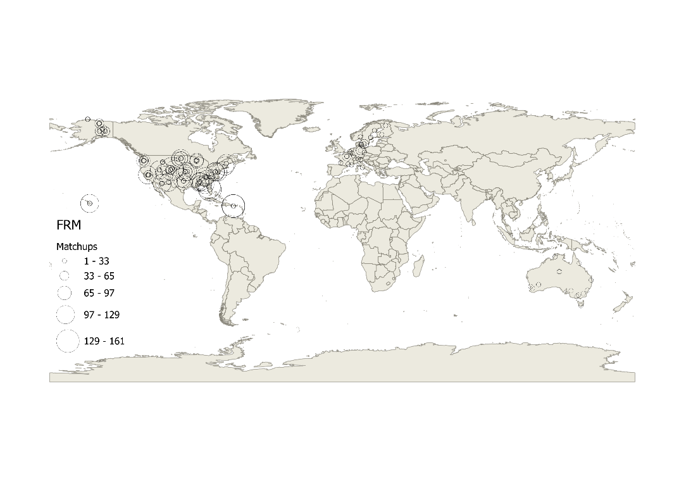
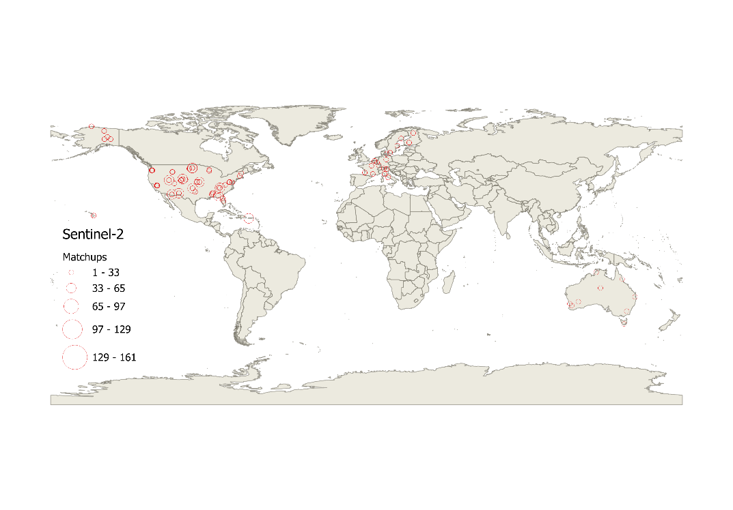
Figure 1. Location of and number of matchups with in-situ FRM for a +/-7day temporal, 60m spatial interval.

Additional variables matchup parameters included the land cover class based on the North American Land Cover Data (NLCD) legend , CI, and WAI.

Exploratory data analysis indicated 62ESUswithin 7 forest sites had having unrealsitically low WAI (Appendix 1). It was determinedas these were estimated using defalt values rather than plot specific data. Here, the WAI for these sites was estimated using line fits versus PAI for other allsites with the same land cover and the LAI and its uncertainty was also updated (Appendix 1).

Each ESU was visually assessed for spatial heterogeneity of land cover and vegetation density using the most recent high resolution ESRI WorldImagery and Google Earth Pro imagery (e.g. .Figure 2) Sites were classified as homogeneous within a 60m radius of the ESU centroid, homogeneous within only a 30m radius of the centroid, or heterogeneous within a 30m radius of the centroid . The 30m radius is approximately the spatial support of in-situ measurements. The 60m radius contains at least a 3x3 patch of nominal 30m Landsat HLS pixels after accounting for worst case 30m geoloction error.

Figure 2. Example of visually assessed ESU heterogeneity.
https://www.usgs.gov/media/files/landsat-8-9-collection-2-level-2-science-product-guide) and a poinst spread function within non-neglible gain at 60m from the nominal pixel centre.

Table 5. Description of in-situ FRM networks.
 | Network
 | ICOS | NEON | TERN
Spatial Extent | European Union, UK | United States of America | Austrailia
Start Date | 2017 | 2013 | 2011
End Date | 2022 | 2022 | 2023
#Sites | 20 (20) | 47 (45) | 14 (14)
#ESUs | 420 (324) | 947 (821) | 21 (19)
#FRM | 1776 (1442) | 11464 (10013) | 154 (146)
#ESUs intraannual | 54 (44) | 144 (121) | 4 (4)

3.2 Land cover

Global land cover data was required to stratify Stage 4 validation. The10m resolution circa 2020 ESA WorldCover 10m v200 was used to specify other vegetation, non-vegetation, and forest land cover groups. The Forest land cover group was dubdivided into broadleaf and needle leaf forests using the 30m resolution Land Cover of North America NALCMS 2020 (https://developers.google.com/earth-engine/datasets/catalog/USGS_NLCD_RELEASES_2020_REL_NALCMS) over North America and, the 2019 100m resolution Copernicus Global Land Cover Layers: CGLS-LC100 Collection 3 (https://developers.google.com/earth-engine/datasets/catalog/COPERNICUS_Landcover_100m_Proba-V-C3_Global ) elsewhere.

Table 6 Land cover group definition.
WorldCover | NALCMS 2020 | CGLS LC100 | NLCD Class | Group
Tree cover | Temperate or sub-polar needleleaf forest  Sub-polar taiga needleleaf forest | Closed forest, evergreen needle leaf.  Closed forest, deciduous needle leaf  Open forest, evergreen needle leaf.  Open forest, deciduous needle leaf. | Evergreen forest  Mixed Forest | NF
Tree cover | Not needleaf classes | Not needleaf classes | Deciduous Forest  Woody wetlands | BF
Shrubland |  |  | Shrub Scrub | OV
Grassland |  |  | Grassland/Herbaceous  Pasture/hay | OV
Cropland |  |  | Culitvated Crops | OV
Built-up |  | Developed | Developed | NV
Bare / sparse vegetation |  | Barren Land | Barren Land  Dwarf Scrub | OV
Snow and ice |  | Perennial snow/ice cover | Perennial snow/ice cover | NV
Permanent water bodies |  | Open water | Open water | NV
Herbaceous wetland |  |  | Sedge Herbaceous  Emergent Herbaceous Wetlands | OV
Mangroves |  |  |  | BF
Moss and lichen |  |  | Lichens  Moss | OV

3.3 Fundamental Data Records

FDRs corresponded to all 30m resolution clear-sky snow and water free land land Harmonized Landsat and Sentinel-2 (HLS) Nadir Bidirectional Reflectance Distribution Function Adjusted Reflectance (NBAR) measurments from the Landsat 8 and 9 OLI from 11/04/2013 onwards from the Google Earth Engine https://developers.google.com/earth-engine/datasets/catalog/NASA_HLS_HLSS30_v002 collection (HLSS30) and Sentinel 2A,b,c MSI from https://developers.google.com/earth-engine/datasets/catalog/NASA_HLS_HLSL30_v002 (HLS-S30) from 28/11/2015 intersecting a 60m radius buffer centred on each FRM ESUs (ESU) and a global 100km x 100km grid (Global).
Measurements were considered clear-sky if the FMASK layer indicated low aerosol cloud and cloud shadow free conditions and also considered snow amd water free based on FMASK flags.

3.4 Thematic Data Products

There are numerous algorithms for producing decametric resolution LAI/FAPAR products from suitable systematelliy acquired FDRs (xx). Here the Simplified Level 2 Prototype Processor (WB, 2020) for a number of reasons:

- it is globally applicable to both Landsat 8/9 Operational Line Imager (OLI) and Sentinel-2 Multispectral Instrument (MSI) decametric resolution FDRs
- it provided associated theoretical uncertainty estimates with each product measurement
- it is widely available in open source code and has been evaluated in previous studies

SL2P uses separate sensor specific single hidden layer neural networks to estimate LAI, FAPAR and their uncertainties (uLAI and uFAPAR) given input surface bi-directional reflectance (hereafter reflectance) from a subset of either OLI or MSI bands (Table 3).

Networks are trained from a calibration database of 42748 simulations of reflectance for a random sample of Landsat 8 OLI spectral bands and nominal global acquisition geometries for either OLI (Sl2P-OLI) or MSI (SL2P-MSI) FDRs.

The land surface condition for each simulation is drawn by orthogonal sampling from a joint distribution of vegetation structure and leaf and soil optical properties specified by fitting to global in-situ and in-vivo measurements available prior to algorithm definition. Reflectance is simulated using using the SAILx canopy reflectance model and the PROSPECTxx leaf optical model together with both additive and multiplicative noise corresponding to nominal sensor reflectance measurement uncertainty. SL2P estimates were discarded if the input reflectance does not match at least one calibration sample within 0.05 in each band or the output estimate exceeds the range of the calibration database.

3.5 Climate Data

Gridded daily 1.1312 km resolution ERA5-Land Daily Aggregated - ECMWF Climate Reanalysis (Muñoz Sabater et al., 2019) layers archived within Google Earth Engine were sampled to produce annual climate parameters spatially coincident with thematic data products. Parameter included the total growing degree days above a base temperature of 10d C (GDD), the total number of days with daily minimum soil temperature for the layer between 0 and 7cm depth greater than 0 degrees C (FROST) , and the ratio of potential evapotranspiration to precipitation (ARID). The uncertainty of GDD, FROST, and ARID was estimated as their temporal range between 2013 and 2025 inclusive.

3.6 Stage 3 Validation

Validation experiments were performed using different ombinations of input FDR and mandatory condition parameters that assigned an inclusion probability of zero between matchups unless they shared the same condition (Table xx).

Additionally, to facilitate comparisons between treatments when the sampled matchups will differ, the expected value of quality statistics conditional on ether the reference or product measurement was estimated using regression models. Previous studies used weighted polynomial regression, with weights inversely proporitional to the confidence interval of the statistics for each matchup (Fernandes, xx). However, this approach will be biased in the presence of outliers and could result in oscillatory fits for undersampled measurements. These concerns are addressed here using a two step approach. First, a multivariate Thiel-Sen regression is used to fit regressors Thchebyshev polynomials of the product or reference measurement to the estimates of each statistic for matchups. Then, the largest 28% residuals are discarded and a weighted oridinatry least squares regression of Thchebyshev polynomials is fit to the remaining data, with weights corresponding to the inverse of the squared confidence interval. The confidence intervals of the regression model allows for comparison of quality staistics between treatments although the models are not to be confused with conformity tests that are performed for each matchup.

Modelling Inclusion probabilities

Estimates of variables and their uncertainty were associated with matchups and global product samples to model inclusion probbailities using Equation xx (Table xx). For both cases, variables related to growing season length index (GSLI) and annual aridity index (AI) were defined. The AI adopted the widely use ratio of annual PET to P. The GSLI corresponded to the geometric mean of the annual accumulated GDD and the annual number of days with Tsoil>0. The geometric mean was used as both quantities are highly correlated. None of these variables have fiducial estimates of uncertainty that can be used when estimating inclusion probabilities. Instead we arbitrarily apply an uncertainty corresponding to the empirical within land cover group standard deviation over the FRM as an indicator of natural variability that includes measurement error.

For matchups only, in-situ LAI, FAPAR, WAI, and CI were added to describe error conditions related to canopy structure. For global samples only product estimates of LAI, fAPAR were
used for to describe canopy structure. In both circumstances the FRM or product uncertaties are applied.

Additionally, except when quantifying stability, the theoretical uncertainty estimate of either LAI or FAPAR from SL2P was also added to describe error conditions related to input FDrs. The uncertainty of these variables was approximated as 0.1 for LAI and 0.01 for FAPAR based on SL2P numerical cross-validaton (Weiss and Baret, 2020) as app

4.3 Stratification

All product measurements were associated with a land cover group from the overlay of available land cover maps based on Table xx. Additionally, the uniformity of FRM ESUs was assessed for mid-growing season conditions by visual assessment of both 60m buffer polygon and 30m buffer polygon centered on the nominal ESU centre. ESUs were classified as uniform (partially uniform) if the 60m (30m) buffer polygon was assessed as having niform land cover and vegetation density from high resolution imagery and non-uniform otherwise.

4.4 Stage 3 Experiments

Multiple stage 3 validation experiments were conducted for each land cover group using all HLS matchups using SL2P-OLI or alternatively only HLS-S30 matchups using SL2P-MSI. Uncertainty and stability we only reported for matchups with at least 10 effective degrees of freedom to increase the reliability of coverage intervals.
Table 7. Validation experiments.
Experiment | Mandatory Conditions | Preferred Conditions | Spatial Buffer | Temporal Buffer | Uniformity | FDR
HLS-SiteUni | Land cover, site | FRM, CI, WAI, PM, PM uncertainty, Climate, | 30m | 1d | Uniform | HLS
HLS-SiteUniWide | Land cover, site | FRM, CI, WAI, PM, PM uncertainty, Climate, | 60m | 7d | Uniform | HLS
HLS-SiteAll | Land cover, site | FRM, CI, WAI, PM, PM uncertainty, Climate, | 30m | 1d | All | HLS
HLS-SiteAllWide | Land cover, site | FRM, CI, WAI, PM, PM uncertainty, Climate, | 60m | 7d | All | HLS
HLS-All | Land cover | FRM, CI, WAI, PM, PM uncertainty, Climate, | 30m | 1d | All | HLS
HLS-AllWide | Land cover | FRM, CI, WAI, PM, PM uncertainty, Climate, | 60m | 7d | All | HLS
HLS-SiteAllWideNoClim | Land cover | FRM, CI, WAI, PM, PM uncertainty, | 60m | 7d | All | HLS
S2-AllWide | Land cover | FRM, CI, WAI, PM, PM uncertainty, Climate, | 60m | 7d | All | S2
HLS-Stage4AllWide | Land cover, not site | FAPAR/LAI PM ratio, PM, PM uncertainty, CLIM | 60m | 7d | All | HLS

For each expertiment uncertainty, relative standard uncertainty, stability, bias and the ir associated estimation confidence intervals were computed based on Secttion 2.5. The probability that a product conformed with GCOS requirements for each matchup was validated assuming a coverage factor of 1 and 1.5.

Quality statistics conditioned on reference and product measurements are also reported to facilitate comparison across different sample sets. Previous studies useweighted polynomial regression as it gives an unbiased estimate of thee conditional staistics as well as confidence intervals (Fernandes et al. 2024). Here we use weighted multivariate Thiel-Sen regression using Thechebyshev polynomials to estimate the conditional response statistics. This approach provides statistically consistent estimates of the expected conditional value that is also roust to up to 28% outliers. Thiel-Sen regression has lower statisticaly efficiency that weighted oridinatry least squares regression but this was deemend not a major issue when applied to large samples (>100) of mactcups.

4.5 Stage 4 Experiments

As discussed in Section 2, Stage 4 validation relies on errors observed at matchups to estimate quality statistics elsewhere. In principle, the approach based on matchup errors weigthed by inclusion probabilities could be applied elsewhere. However, the inclusion probabilities will likely be less precise that those modelled during Stage 3 validation due to the lack of in-situ variables to quantify measurement conditions. Furthermore, these weighted estimates are local point estimators even though systematic errors tend to change relatively smoothly as a function of product measurement. Here we use heteroskedactic GPR estimators as these both account for uncertainty of independent variables during calibration and produce estimates based on a weighted combination of smooth functions. For simplicity this is only calibrated for the baseline stage 3 sampling.

The GPR approach provides an estimate of the uncertainty of quality statistics assuming the matchup conditions represent the product measurement conditions. The additional increase in this uncertainty is quantified by comparing the stage 3 and stage 4 estimates of uncertainty after holding out entire sites when GPR calibration. The average relative increase in uncertainty was used as the coverage factor to increase the confidence interval of GPR estimates when testing coformity. The probability of conformity of product measurements was assessed for standard uncertainty and stability statistics.

Results

Allowing within site comparisons using all matchups resulted in a small increase in n compared to using only matchups with homogeneous FRM for both LAI and FAPAR (). However, a large increase in n was observed when matchups within a +/-7d temporal interval and 60m buffer were allowed. This increase was even more pronounced for FAPAR due to the saturation of FAPAR over forests sites.

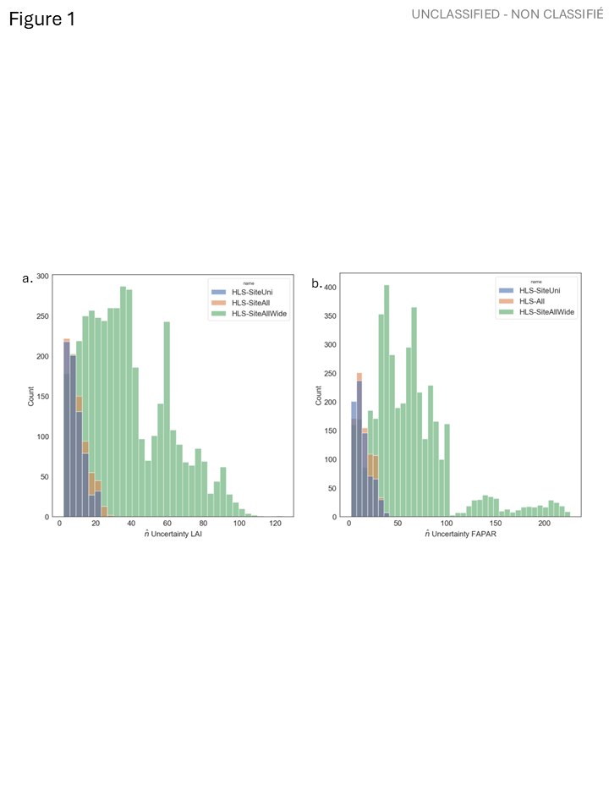
Figure 3 Comparison of effective degrees of freedom for uncertainty estimates for (a) LAI and (b) FAPAR experiments.

Site specific quality statistics were virtually identical between experiments using only homogeneous versus all FRM (Supplementary Material S1). This suggests that the statistical estimators are robust to errors in residuals due to site heterogeneity and that validation results using all sites are sufficient. Subseuqnetly, only results for experiments using all FRM are presented in detail although the conformity of product measurements to user requirements is summarized for all experiments ().

Table 8. Summary of uncertainty (U) and stability (S) GCOS validation for product measurements (PM) for each experiment described in xx.
Experiment | Validated PM | U Conformity |  |  | S Conformity
 | # | %True | %False | %Incon. | %True | %False | %Incon.
HLS-SiteUni
HLS-SiteUniWide
HLS-SiteAll
HLS-SiteAllWide
HLS-All
HLS-AllWide
HLS-SiteAllWideNoClim
S2-AllWide
HLS-Stage4AllWide

Site specific quality staistics using a wide matchup interval were comparable in magnitude to using only +/-1d, 30m intervals although LAI stability could not be compared as there were no matchups with n >=10 for the latter (Figure 2 and Figure 3). Accuracy and bias were almost always within one confidence interval of the 1:1 line for both LAI and FAPAR. Uncertainty showed the same behaviour for the majority of comparisons although uncertainty estimated using a wider interval was up to 50% greater than for narrow intervals. This is expected since the wider interval potentially samples a greater range of matchup conditions. A similar patter was observed for LAI stability although the significance of differences between experiments was likely lower due to the large uncertainty of both LAI and FAPAR stability for narrow intervals. Subseuqnetly, only results for experiments using all FRM with wide intervals are presented.
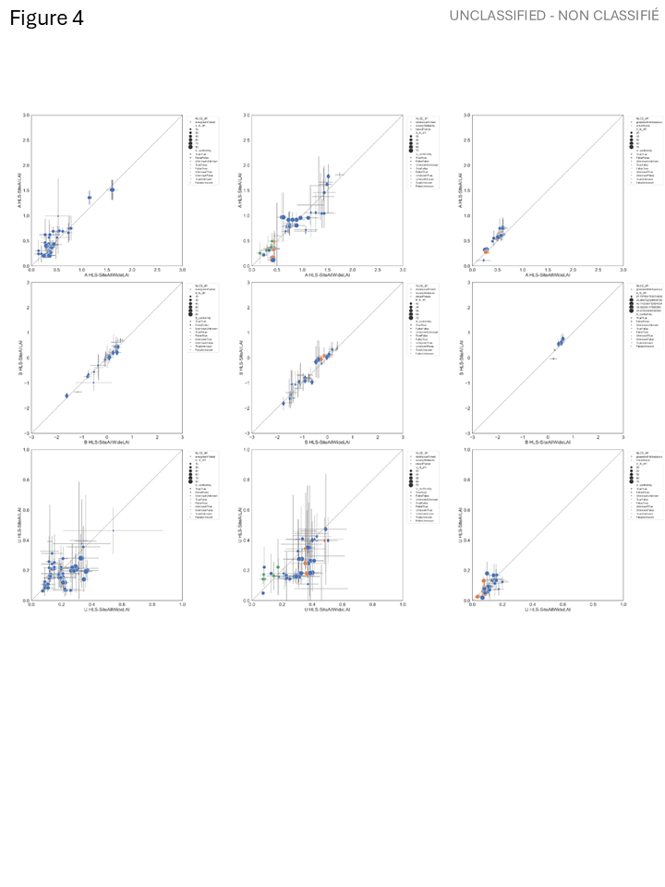
Figure 4 Comparison of LAI quality statistics for site specific experiments using all FRM with wide matchup intervals(x-axis) and only all FRM with narrow matchup intervals (y-axis). Whiskers correspond to one standard deviation confidence intervals. Colors indicate land cover class. Shape indicates conformity to GCOS requirements for the all FRM experiment. Stability not presented due to lack of matchups with effective degrees of freedom >=10.

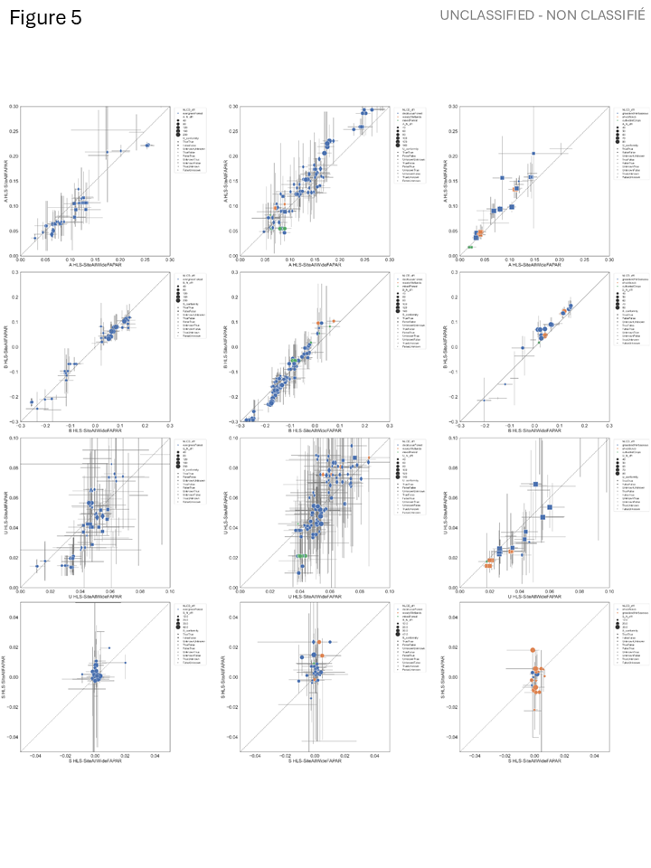
Figure 5 Comparison of FAPAR quality statistics for site specific experiments using all FRM with wide matchup intervals(x-axis) and only all FRM with narrow matchup intervals (y-axis). Whiskers correspond to one standard deviation confidence intervals. Colors indicate land cover class. Shape indicates conformity to GCOS requirements for the all FRM experiment.

Site specific LAI validation results (Figure 6) indicate that B is a large component of A for all land cover groups. While A was generally proportional to LAI, B increased somewhat with LAI for broadleaf forests but not as much for other land cover groups. That said, estimates of bias using our method were similar to estimates based on the curve fitting approach of Fernandes et al. (xx) who assume bias was a polynomial function of LAI (compare red and black curves for B panels). In contrast estimates of U by curve fitting of bias corrected absolute residuals were on the order of twice as large as those using our methods. This follows since the former assumes a uniform inclusion probability for similar LAI and subsequently includes variability in residuals across matchup conditions that our approach addresses by weighting with inclusion probabilities. Curve fitting methods are also extremely prone to biases due to irregular sampling as seen for estimates of all staistics for the OtherVegetation group. Using our methods, xx% (xx%) of comparisons were identified as conforming (not conforming) with GCOS uncertainty requirements assuming a coverage factor of 1. Nevertheless, both the LAI U and LAI S confidence intervals were frequently larger than estimated validation statistic. The combination of wide LAI S confidence intervals and narrow S tolerance interval led to only xx% of matchups satisfying GCOS stability requirements and xx% inconslusive matchups. It is noteworthy that, unlike U, the confidence interval for S decreases with the number of years over which B is observed for the matchups so the situation may improve with longer FRM time series.

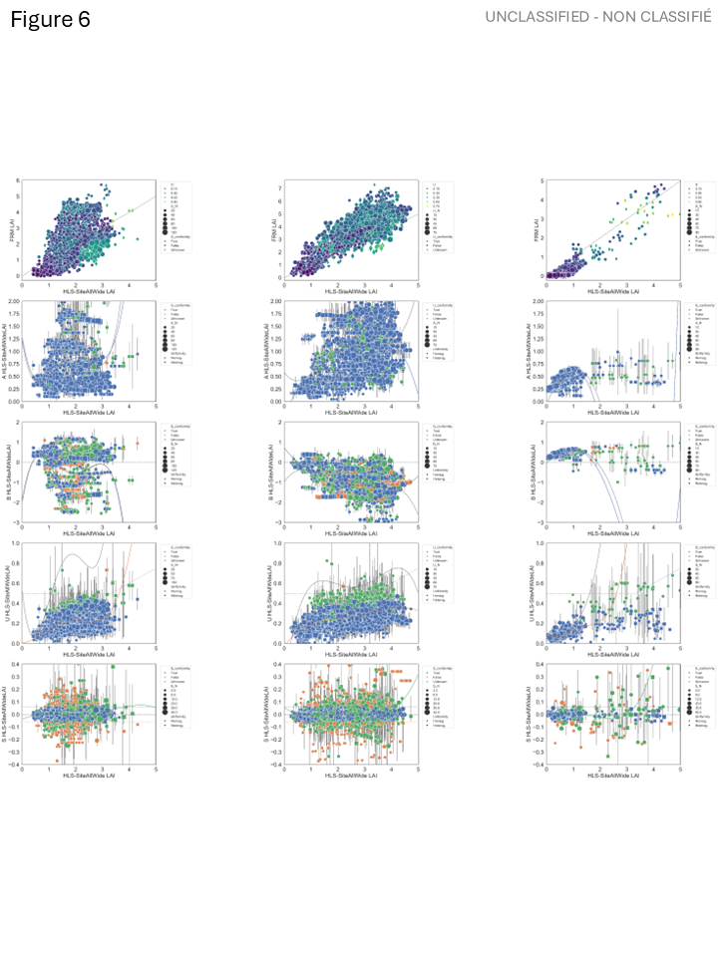
Figure 6. Scatter plots of product versus FRM LAI (top row) and estimated A, B, U and S (subsequent rows) for land cover groups (columns) for validation of the SL2P algorithm applied to site specific HLS matchups within +/-7days and 60m radius of in-situ FRM. Symbol size proportion to effective degrees of freedom, symbol colour indicates conformity to GCOS U requirements (shown for product versus FRM, A and U plots) or S conformity (for B and S plots), symbol shape indicates FRM ESU heterogeneity. Whiskers indicate one standard deviation confidence intervals of estimates. Black curves correspond to estimates based on Fernandes et al. (2024) approach, red or green curves correspond to robust polynomial fits through data points.

Site specific validation results for FAPAR also show differences between our method and that of Fernandes et al. (2024) but this time for U rather than B. This may be due to the fact that FAPAR B is indeed strongly correlated to the product measurement FAPAR. This result clearly indicates that FAPAR U is likely much lower than previously quantified for the SL2P algorithm although only xx% matchups conformed to GCOS U requirements due to narrow tolerance interval for FAPAR. This narrow interval also resulted in xx% inconclusive matchups. However, FAPAR S only had xx% inconclusive matchups and xx% conforming matchups. This may suggests that, in comparison to LAI, FAPAR is less sensitive to drifts in input FDRs but it could also be simply due to the fact that FAPAR saturates during the growing season so all retrievals have similar values for the same condition.

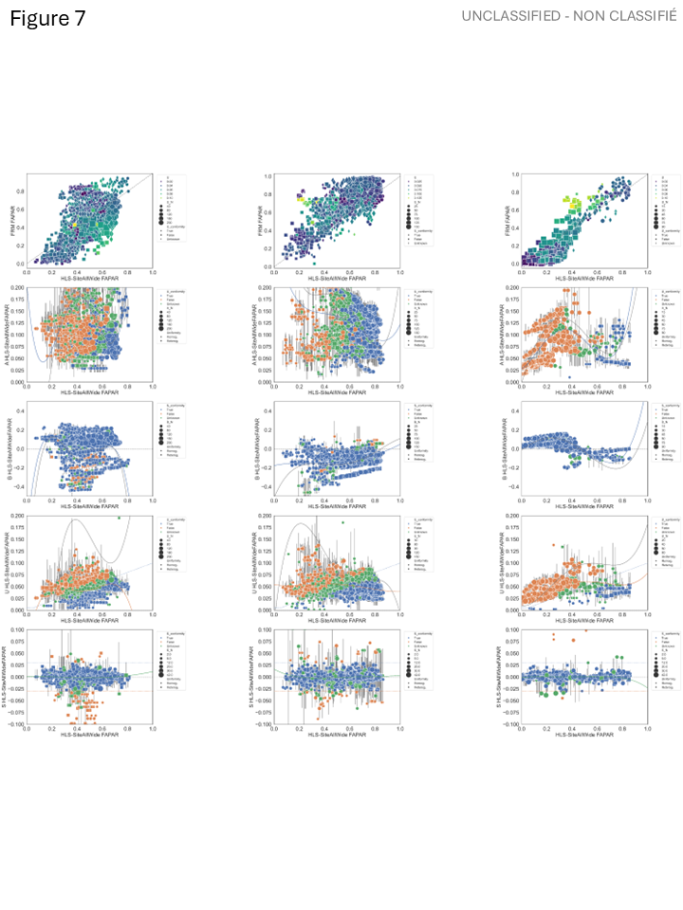
Figure 7. Scatter plots of product versus FRM FAPAR (top row) and estimated A, B, U and S (subsequent rows) for land cover groups (columns) for validation of the SL2P algorithm applied to site specific HLS matchups within +/-7days and 60m radius of in-situ FRM. Symbol size proportion to effective degrees of freedom, symbol colour indicates conformity to GCOS U requirements (shown for product versus FRM, A and U plots) or S conformity (for B and S plots), symbol shape indicates FRM ESU heterogeneity. Whiskers indicate one standard deviation confidence intervals of estimates. Black curves correspond to estimates based on Fernandes et al. (2024) approach, red or green curves correspond to robust polynomial fits through data points.Extending allowable matchups to all sites does not appreciably bias estimates of accuracy, bias although uncertainty is FAPAR uncertainty is frequently overestimated compared to site specific matchups (Figure 4 and Figure 5 ). Stability comparisons indicate agreement within +/-0.1 LAI/year and +/-0.01 FAPAR/year for most sites but outliers are present. Evan so, the dispersion is centred on the 1:1 line so estimates of stability condition on LAI or FAPAR are virtually identical (Supplementary Material S2). This result reflects the influence of ancillary climate parameters on similarity that weigh within site matchups heavily when computing quality statistics for a matchup.

Our method also allows for comparison of quality statistics and validation results between different products – in this case between outputs of the SL2P algorithm for OLI bands applied to all HLS data data and the SL2P algorithm for MSI bands applied to HLS-S30 data (labelled here S2). While this comparison could be performed by only considering FRM where both products have matchups simultaneously this result will incorporate variability across matchup conditions that is acurally the same for both products and actually only needed to test conformity. Instead, we present aggregate conformity statistics (Table 6) and curves corresponding to quality staistics conditional on the product measurement (Figure 8,Figure 9 ). These results indicate that both products are almost similar in all statistics for each land cover group, with S2 products showing slightly lower bias over needleleaf forests than HLS products and vice versa for broadleaf forests. Additioally, S2 products had a conformity of 91% for U versus 90% for HLS. The only major difference being a S2 conformity of 83% for S versys 58% for HLS although this was mainly due to a higher percentage of HLS inconclusive results of 29% versus 15% for S2.

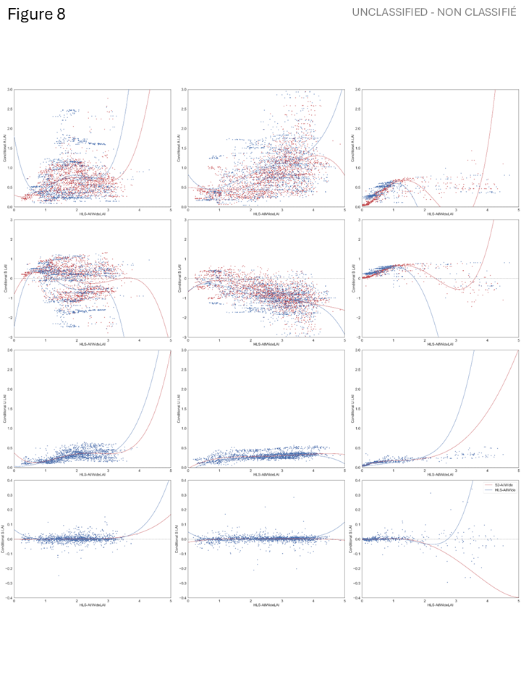
Figure 8 Comparison of site specific LAI quality statistics between SL2P-S2 (red points) and SL2P-HLS algorithms (blue points) together with curves corresponding to statistics conditional on the product measurement of LAI.
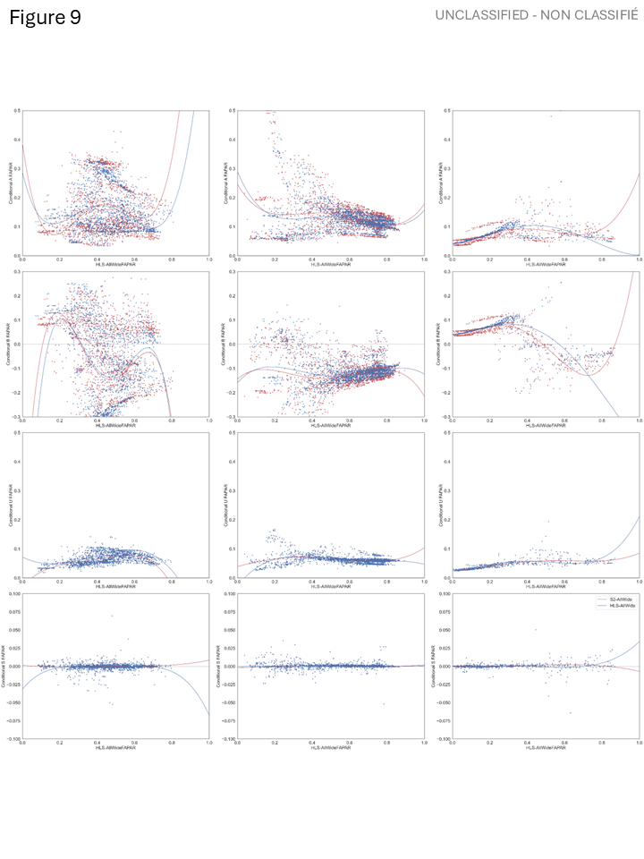
Figure 9 Comparison of site specific FAPAR quality statistics between SL2P-S2 (red points) and SL2P-HLS algorithms (blue points) together with curves corresponding to statistics conditional on the product measurement of FAPAR.

Figures S3.1 and S3.2 both suggest that moving from site specific conditions to conditions over all matchups will result in negligible differences in estimates of validation statistics other than stability. Even stability will still be unbiased but there will be greater variability as sites with different phenology conditions may be included when computing annual biases required for stability.

Supplementary Material S1 – Comparison of Site Specific Quality Statistics as a function of heterogeneity.

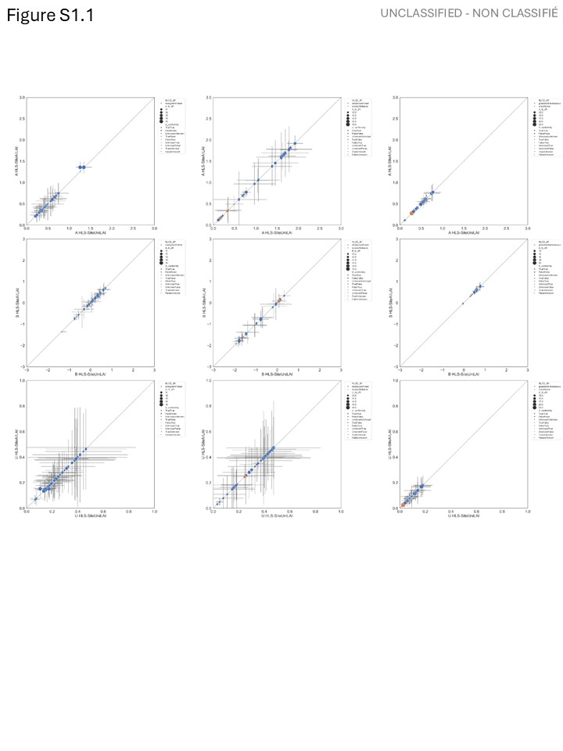
Figure S1.1 Comparison of LAI quality statistics for site specific experiments using all FRM (x-axis) and only homogenous FRM (y-axis). Whiskers correspond to one standard deviation confidence intervals. Colors indicate land cover class. Shape indicates conformity to GCOS requirements for the all FRM experiment. Stability not presented due to lack of matchups with effective degrees of freedom >=10.

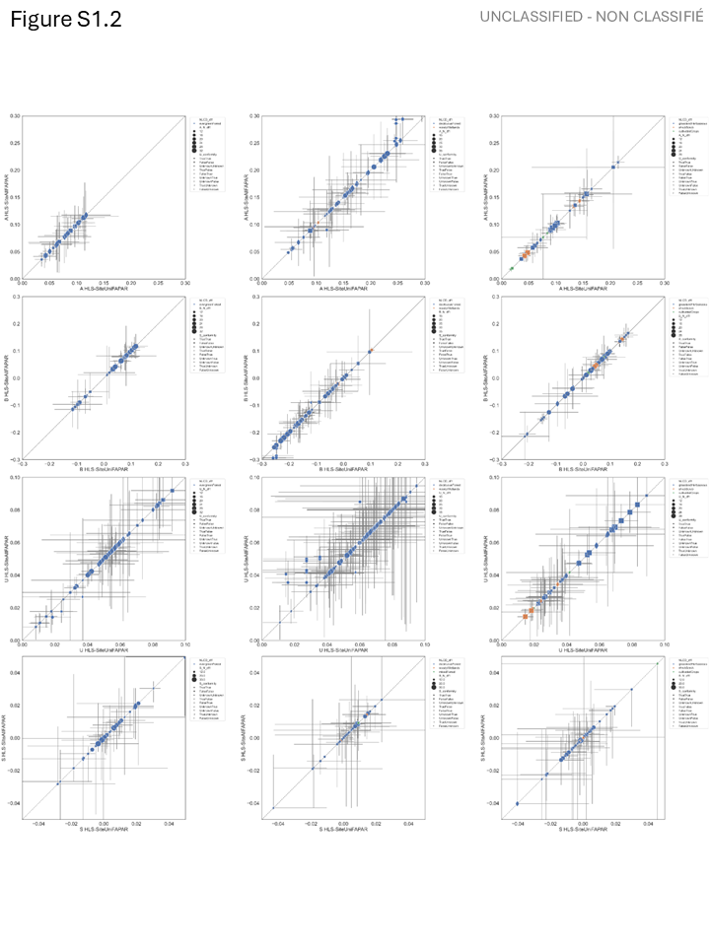
Figure S1.2 Comparison of FAPAR quality statistics for site specific experiments using all FRM (x-axis) and only homogenous FRM (y-axis). Whiskers correspond to one standard deviation confidence intervals. Colors indicate land cover class. Shape indicates conformity to GCOS requirements for the all FRM experiment.

Supplementary Material S2 – Comparison of conditional quality statistics between site specific and all sites matchup experiments for wide interval sampling

Figure S1.2 Conditional LAI quality statistics based on only site specific matchups (red) and all matchups (blue). (Note: I will add scatter plots of all matchups for context).

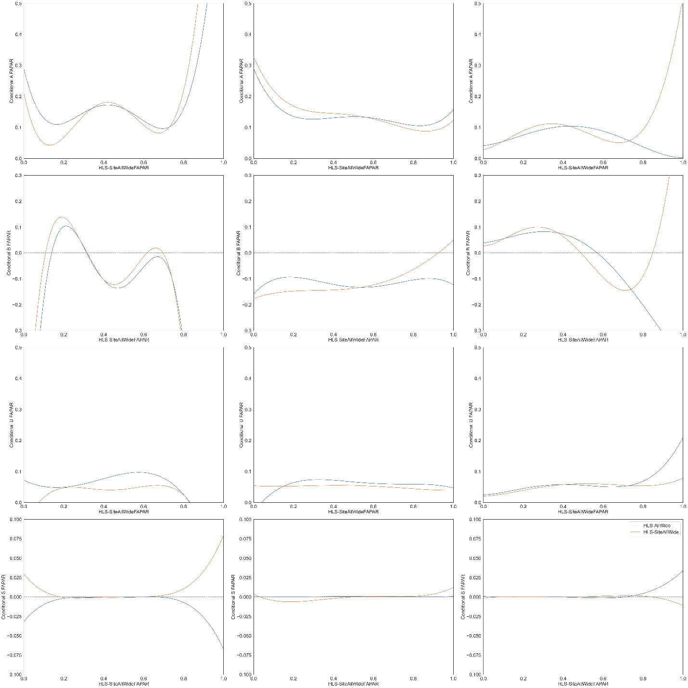
Figure S2.2 Conditional FAPAR quality statistics based on only site specific matchups (red) and all matchups (blue). (Note: I will add scatter plots of all matchups for context).

Supplementary Material S3 – Comparison of quality statistics between site specific and all site matchup conditions.

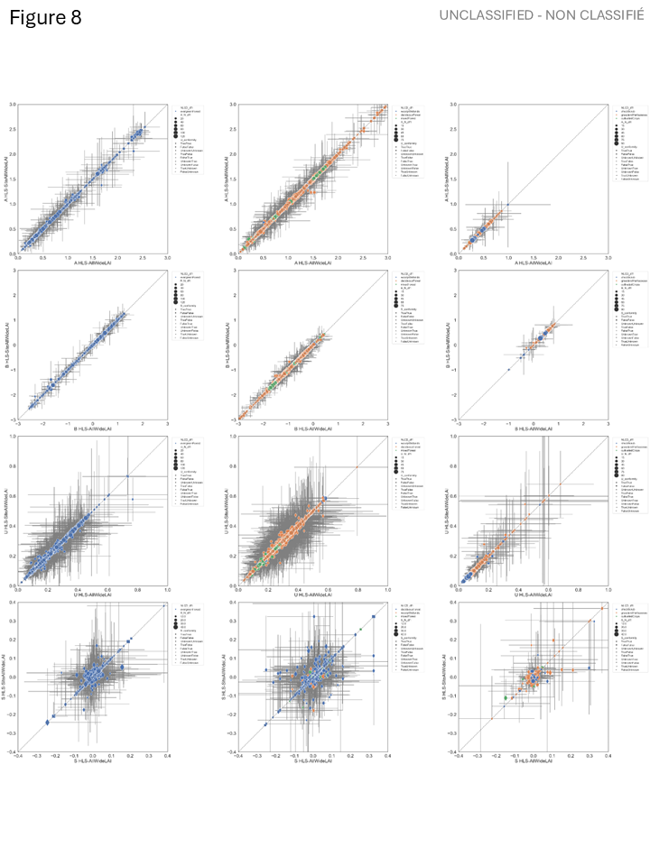
Figure S3.1 Comparison of LAI quality statistics between site specific experiments using all FRM with wide matchup intervals(x-axis) and all FRM with wide matchup intervals (y-axis). Whiskers correspond to one standard deviation confidence intervals. Colors indicate land cover class. Shape indicates conformity to GCOS requirements for the all FRM experiment for both experiments.

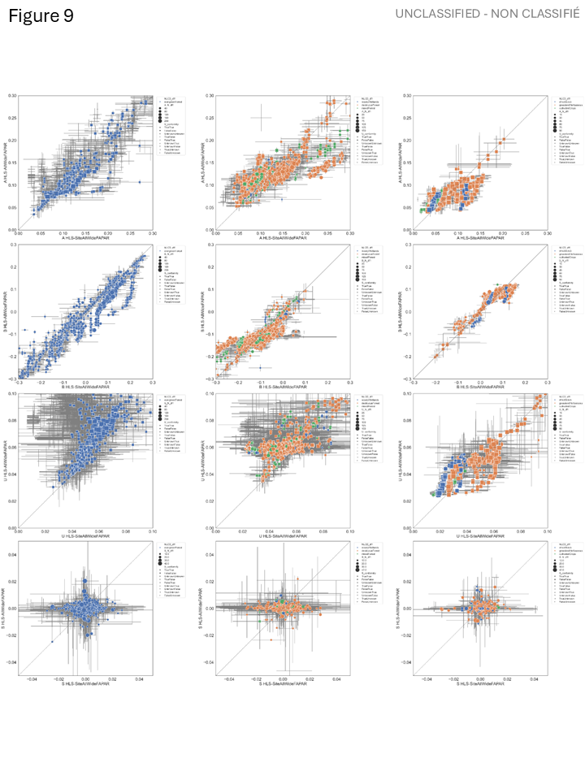
Figure 3.2 Comparison of FAPAR quality statistics between site specific experiments using all FRM with wide matchup intervals(x-axis) and all FRM with wide matchup intervals (y-axis). Whiskers correspond to one standard deviation confidence intervals. Colors indicate land cover class. Shape indicates conformity to GCOS requirements for the all FRM experiment for both experiments.

Discussion

Conclusion

(C

Uuu)) =

SS

B

yE-yEe-Bbe

MPEEEAAae

u

pee

p=1a

p=1

- =-
- =-
- =-f fyxfxx

==

a

u ay

P(e)

- eP(e)

P(e)eyyy>00≥y≤1P(e)P(e)P

=

=

P()P()P(e)P()

uSau()a()=a()b()S

P(e)

N
=

=

Nn

=n

,
=
,

=

PCP>0.0015
=

,
=
,

=

.

Acknowledgements

References

Lehmann, E. L., & Casella, G. (1998). Theory of Point Estimation. Springer.

Kendall, M.G. and Stuart, A. (1969) The Advanced Theory of Statistics, Vol. 1. Hafner Publishing Company, New York.

Brown LA, Camacho F, García-Santos V, Origo N, Fuster B, Morris H, Pastor-Guzman J, Sánchez-Zapero J, Morrone R, Ryder J, et al. Fiducial Reference Measurements for Vegetation Bio-Geophysical Variables: An End-to-End Uncertainty Evaluation Framework. Remote Sensing. 2021; 13(16):3194. https://doi.org/10.3390/rs13163194
Brown, L. A., Meier, C., Morris, H., Pastor-Guzman, J., Bai, G., Lerebourg, C., Gobron, N., Lanconelli, C., Clerici, M., & Dash, J. (2020). Evaluation of global leaf area index and fraction of absorbed photosynthetically active radiation products over North America using Copernicus Ground Based Observations for Validation data. Remote Sensing of Environment, 247, 111935.
Brown, L., Fernandes, R., Djamai, N., Meier, C., Gobron, N., Morris, H., Canisius, F., Bai, G., Lerebourg, C., Lanconelli, C., Clerici, M., & Dash, J. (2021). Validation of baseline and modified Sentinel-2 Level 2 Prototype Processor leaf area index retrievals over the United States. ISPRS Journal of Photogrammetry and Remote Sensing, 175, 71–87. https://doi.org/10.1016/j.isprsjprs.2021.02.020
Brown, L.A., Fernandes, R., Verrelst, J., Morris, H., Djamai, N., Reyez-Muñoz, P., D.Kovács, D., Meier, C. (2025). GROUNDED EO: Data-driven Sentinel-2 LAI and FAPAR retrieval using Gaussian processes trained with extensive fiducial reference measurements, Remote Sens. Environ., https://doi.org/10.1016/j.rse.2025.114797.
Camacho F, Martínez-Sánchez E, Brown LA, Morris H, Morrone R, Williams O, Dash J, Origo N, Sánchez-Zapero J, Boccia V. Validation and Conformity Testing of Sentinel-3 Green Instantaneous FAPAR and Canopy Chlorophyll Content Products. Remote Sensing. 2024; 16(15):2698. https://doi.org/10.3390/rs16152698
Camacho, F., García-Haro, F. J., Sánchez-Zapero, J., & Fuster, B. (201a). The EUMETSAT Satellite Application Facility on Land Surface Analysis: Validation report – MSG/SEVIRI vegetation parameters (VEGA) (Issue 3.1, Reference No. SAF/LAND/UV/VR_VEGA_MSG). EUMETSAT.
Camacho, F., García-Haro, F.J., Sánchez-Zapero, J. Fuster, N. (2018b). Validation Report MSG/SEVIRI Vegetation Parameters (VEGA), Ref: SAF/LAND/UV/VR_VEGA_MSG Issue: Version 3.1 Updated: 6 March 2018, accessed at https://nextcloud.lsasvcs.ipma.pt/s/LbAmqBTB3Q2tbQP?dir=/VR-Validation_Report&openfile=true on September 25, 2025.
Campos-Taberner, M., García-Haro, F. J., Camps-Valls, G., Grau-Muedra, G., Nutini, F., Busetto, L., Katsantonis, D., Stavrakoudis, D., Minakou, C., Gatti, L., Barbieri, M., Holecz, F., Stroppiana, D., & Boschetti, M. (2017). Exploitation of SAR and Optical Sentinel Data to Detect Rice Crop and Estimate Seasonal Dynamics of Leaf Area Index. Remote Sensing, 9(3), 248. https://doi.org/10.3390/rs9030248
Cao, S., Li, M., Zhu, Z., Wang, Z., Zha, J., Zhao, W., Duanmu, Z., Chen, J., Zheng, Y., Chen, Y., Myneni, R. B., and Piao, S. (2023). Spatiotemporally consistent global dataset of the GIMMS leaf area index (GIMMS LAI4g) from 1982 to 2020, Earth Syst. Sci. Data, 15, 4877–4899, https://doi.org/10.5194/essd-15-4877-2023.
CEOS, (2008). Committee on Earth Observation Satellites Working Group on Information Systems and Services Interoperability Handbook, Issue 1.1, http://ceos.org/document_management/Working_Groups/WGISS/Documents/WGISS_CEOS-Interoperability-Handbook_Feb2008.pdf.
CEOS, 2018. Space Agency Response to GCOS Implementation Plan, version 2.2.1, © The Joint CEOS/CGMS Working Group on Climate (WGClimate), 2018.

CEOS, 2025. Roadmap towards an Assessment Framework for CEOS-Fiducial Reference Measurements (FRMs) Version 2.0 – July 2025, https://calvalportal.ceos.org/documents/10136/958898/CEOS-FRM_Assessment_Framework_V2_20250704.pdf/e4bda462-018d-4a12-5d01-4103b0faed6c?t=1751618407348

Chabrillat, S; Guanter, L.; Kaufmann, H.; Foerster, S.; Beamish, A.; Brosinsky, A.; Wulf, H.; Asadzadeh, S.; Bochow, M.; Bohn N.; Boesche, N.; Bracher, A.; Brell, M.; Buddenbaum, Cerra, D.; H.; Fischer, S.; Hank, T.; Heiden, U.; Heim, B.; Heldens, W.; Hill, J.; Hollstein, A.; Hostert, P.; Krasemann, H.; LaPorta, L.; Leitão, P.J.; van der Linden, S.; Mauser, W.; Milewski, R.; Mottus, M.; Okujeni, A.; Oppelt, N.; Pinnel, N.; Roessner, S.; Röttgers, R.; Schneiderhan, T.; Schickling, A.; Soppa, M.; Staenz, K.; Segl, K. (2022) EnMAP Science Plan. EnMAP Technical Report, GFZ Data Services.
DOI: http://doi.org/10.48440/enmap.2022.001

Choate, M. J., Rengarajan, R., Storey, J. C., & Lubke, M. (2023). Landsat 9 Geometric Commissioning Calibration Updates and System Performance Assessment. Remote Sensing, 15(14), 3524. https://doi.org/10.3390/rs15143524

Djamai, N., Fernandes, R., Sun, L., Hong, G., Brown, L., Morris, H., & Dash, J. (2025). On the consistency and stability of vegetation biophysical variables retrievals from Landsat-8/9 and Sentinel-2. ISPRS Journal of Photogrammetry and Remote Sensing, 224, 329–347. https://doi.org/10.1016/j.isprsjprs.2025.04.006

Defourny, P., Bontemps, S., Bellemans, N., Cara, C., Dedieu, G., Guzzonato, E., Hagolle, O., Inglada, J., Nicola, L., Rabaute, T., Savinaud, M., Udroiu, C., Valero, S., Bégué, A., Dejoux, J.-F., El Harti, A., Ezzahar, J., Kussul, N., Labbassi, K., . . . Koetz, B. (2019). Near real-time agriculture monitoring at national scale at parcel resolution: Performance assessment of the Sen2-Agri automated system in various cropping systems around the world. Remote Sensing of Environment, 221, 551–568. https://doi.org/10.1016/j.rse.2018.11.007

Dubayah, R., Blair, J. B., Goetz, S., Fatoyinbo, L., Hansen, M., Healey, S., Hofton, M., Hurtt, G., Kellner, J., Luthcke, S., Armston, J., Tang, H., Duncanson, L., Hancock, S., Jantz, P., Marselis, S., Patterson, P. L., Qi, W., & Silva, C. (2020). The Global Ecosystem Dynamics Investigation: High-resolution laser ranging of the Earth’s forests and topography. Science of Remote Sensing, 1, 100002. https://doi.org/10.1016/j.srs.2020.100002
Environ. Sci. Pol., 51, pp. 149-169, https://doi.org/10.1016/j.envsci.2015.03.018.
European Space Agency. (2007, February 19). Sentinel-3 mission requirements document (Doc. No. EOP-SM/1151/MD-md v2.0). European Space Agency.
European Space Agency. (2010, March). Copernicus Sentinel-2 mission requirements document (Document No. EOP-SM/1163/MR-dr, i2r0). https://www.esa.int/Applications/Observing_the_Earth/Earth_observation_library/Satellite_mission_documents
Fang, H. et al., (2019b). Validation of global moderate resolution leaf area index (LAI) products over croplands in northeastern China. Remote Sens. Environ., 233, 111377.
Fang, H., Baret, F., Plummer, S., & Schaepman-Strub, G. (2019a). An overview of global leaf area index (LAI): Methods, products, validation, and applications. Reviews of Geophysics. 57, 739–799. https://doi.org/10.1029/2018RG000608
FAO. 2025. Global Forest Resources Assessment 2025. Rome. https://doi.org/10.4060/cd6709en
Fernandes, R., Brown, L., Canisius, F., Dash, J., He, L., Hong, G., Huang, L., Le, N. Q., MacDougall, C., Meier, C., Darko, P. O., Shah, H., Spafford, L., & Sun, L. (2023). Validation of simplified level 2 prototype processor Sentinel-2 fraction of canopy cover, fraction of absorbed photosynthetically active radiation, and leaf area index products over North American forests. Remote Sensing of Environment, 293, Article 113600. https://doi.org/10.1016/j.rse.2023.113600
Fernandes, R., Djamai, N., Harvey, K., Hong, G., MacDougall, C., Shah, H., & Sun, L. (2024). Evidence of a bias-variance trade-off when correcting for bias in Sentinel-2 forest LAI retrievals using radiative transfer models. Remote Sensing of Environment, 305, Article 114060. https://doi.org/10.1016/j.rse.2024.114060
Fernandes, R., Plummer, S., Nightingale, J., Baret, F., Camacho, F., Fang, H., Garrigues, S., Gobron, N., Lang, M., Lacaze, R., Leblanc, S., Meroni, M., Martinez, B., Nilson, T., Pinty, B., Pisek, J., Sonnentag, O., Verger, A., Welles, J., Weiss, M., Widlowski, J.-L., Schaepman-Strub, G., Roman, M., Nickeson, J., 2014. Global Leaf Area Index Product Validation Good Practices, in: Fernandes, R., Plummer, S., Nightingale, J. (Eds.), Best Practice for Satellite-Derived Land Product Validation. Land Product Validation Subgroup (Committee on Earth Observation Satellites Working Group on Calibration and Validation). https://doi.org/10.5067/doc/ceoswgcv/lpv/lai.002
Fernandes, R., Tang, H., and Brown, L. (2024a). Proposed definition of leaf area index by the Committee of Earth Observation Satellites; Geomatics Canada, Open File 86, 7 p. https://doi.org/10.4095/p9fzmg1djq
Fernandes, R., Tang, H., and Brown, L. (2024b). Proposed definition of fraction of absorbed photosynthetically active radiation by the Committee of Earth Observation Satellites; Geomatics Canada, Open File 85, ver. 1.0, 6 p. https://doi.org/10.4095/p3gy844zex
Fuster, B., Sánchez-Zapero, J., Camacho, F., García-Santos, V., Verger, A., Lacaze, R., Weiss, M., Baret, F., & Smets, B. (2020). Quality Assessment of PROBA-V LAI, fAPAR and fCOVER Collection 300 m Products of Copernicus Global Land Service. Remote Sensing, 12(6), 1017. https://doi.org/10.3390/rs1206101

Gascon, F., Bouzinac, C., Thépaut, O., Jung, M., Francesconi, B., Louis, J., Lonjou, V., Lafrance, B., Massera, S., Gaudel-Vacaresse, A., Languille, F., Alhammoud, B., Viallefont, F., Pflug, B., Bieniarz, J., Clerc, S., Pessiot, L., Trémas, T., Cadau, E., ... Fernandez, V. (2017). Copernicus Sentinel-2A Calibration and Products Validation Status. Remote Sensing, 9(6), 584. https://doi.org/10.3390/rs9060584

Gaudel, A. & Languille, F. & Delvit, J. & Michel, J. & Cournet, Myriam & Poulain, V.. (2017). SENTINEL-2 GLOBAL REFERENCE IMAGE VALIDATION AND APPLICATION TO MULTITEMPORAL PERFORMANCES AND HIGH LATITUDE DIGITAL SURFACE MODEL. The International Archives of the Photogrammetry, Remote Sensing and Spatial Information Sciences. XLII-1/W1. 447-454. 10.5194/isprs-archives-XLII-1-W1-447-2017.

GEOGLAM (2022). Full EAV table | AgVariables. Accessed at https://agvariables.org/ on August 12, 2025.
Goryl, P., Fox, N., Donlon, C., & Castracane, P. (2023). Fiducial Reference Measurements (FRMs): What Are They? Remote Sensing, 15(20), 5017. https://doi.org/10.3390/rs15205017

Hu, Q., Yang, J., Xu, B., Huang, J., Memon, M. S., Yin, G., Zeng, Y., Zhao, J., & Liu, K. (2020). Evaluation of Global Decametric-Resolution LAI, FAPAR and FVC Estimates Derived from Sentinel-2 Imagery. Remote Sensing, 12(6), 912. https://doi.org/10.3390/rs12060912

JGCM (2008). Evaluation of measurement data - Guide to the expression of uncertainty in measurement. JCGM 100:2008(E) – in English. https://doi.org/10.59161/JCGM100-2008E
JGCM (2012). The role of measurement uncertainty in conformity assessment. JCGM 106:2012 .https://doi.org/10.59161/JCGM106-2012
JGCM, (2021), International vocabulary of metrology—Basic and general concepts and associated terms,4th ed. Joint Committee for Guides in Metrology JCGM-WG2-CD-01.
JGCM. (2020). Guide to the expression of uncertainty in measurement — Part 6: Developing and using measurement models. JCGM GUM-6:2020. https://doi.org/10.59161/JCGMGUM-6-2020
Ju, J., Zhou, Q., Freitag, B., Roy, D. P., Zhang, H. K., Sridhar, M., Mandel, J., Arab, S., Schmidt, G., Crawford, C. J., Gascon, F., Strobl, P. A., Masek, J. G., Neigh, C. S. R. (2025). The Harmonized Landsat and Sentinel-2 Version 2.0 Surface Reflectance Dataset. Remote Sensing of Environment, 324, 114723. https://doi.org/10.1016/j.rse.2025.114723.
LANCONELLI, C., CAPPUCCI, F., ADAMS, J. and GOBRON, N., Evaluation of in situ FAPAR measurement protocols using 3D radiative transfer simulations, REMOTE SENSING, 16, 23, 2024, p. 4552, MDPI, https://data.europa.eu/doi/10.3390/rs16234552, JRC139442.
Ma, H. and Liang, S. (2022) . Development of the GLASS 250-m leaf area index product (version 6) from MODIS data using the bidirectional LSTM deep learning model Remote Sens. Environ., 273 (2022), Article 112985
Ma, H., Liang, S., Xiong, C., Wang, Q., Jia, A., and Li, B (2022). Global land surface 250 m 8 d fraction of absorbed photosynthetically active radiation (FAPAR) product from 2000 to 2021, Earth Syst. Sci. Data, 14, 5333–5347, https://doi.org/10.5194/essd-14-5333-2022.
Ma, H., Q. Wang, W. Li, Y. Chen, J. Xu, Y. Ma, J. Huang, and S. Liang (2025). The first gap-free 20 m 5-day LAI/FAPAR products over China (2018–2023) from integrated Landsat-8/9 and Sentinel-2 Analysis Ready Data. Remote Sensing of Environment, 331, 115048.DOI: 10.1016/j.rse.2025.115048.
Ma, H., Q. Wang, W. Li, Y. Chen, J. Xu, Y. Ma, J. Huang, and S. Liang (2025). The first gap-free 20 m 5-day LAI/FAPAR products over China (2018–2023) from integrated Landsat-8/9 and Sentinel-2 Analysis Ready Data. Remote Sensing of Environment, 331, 115048.DOI: 10.1016/j.rse.2025.115048.

Malenovský, Z., Rott, H., Cihlar, J., Schaepman, M. E., García-Santos, G., Fernandes, R., & Berger, M. (2012). Sentinels for science: Potential of Sentinel-1, -2, and -3 missions for scientific observations of ocean, cryosphere, and land. Remote Sensing of Environment, 120, 91–101. https://doi.org/10.1016/j.rse.2011.09.026
Monteith, J. L. (1972). Solar Radiation and Productivity in Tropical Ecosystems. Journal of Applied Ecology, 9(3), 747–766. https://doi.org/10.2307/2401901
Navarro, L.M., Fernández, N., Guerra, C., Guralnick, R., Kissling, W.D., Londoño, M.C., et al. (2017). Monitoring biodiversity change through effective global coordination. Curr. Opin. Environ. Sustain., 29, 158–169.
Origo, N., Gorroño, J., Ryder, J., Nightingale, J., & Bialek, A. (2020). Fiducial Reference Measurements for validation of Sentinel-2 and Proba-V surface reflectance products. Remote Sensing of Environment, 241, 111690, https://doi.org/10.1016/j.rse.2020.111690.

M. Schneider, P. Schwind, E. Carmona and T. Storch, "EnMap Geometric Processing and Geometric Performance after One Year of Acquisitions," IGARSS 2023 - 2023 IEEE International Geoscience and Remote Sensing Symposium, Pasadena, CA, USA, 2023, pp. 4670-4673, doi: 10.1109/IGARSS52108.2023.10282784.
keywords: {Spectroscopy;Satellites;Geology;Imaging;Metadata;Surface treatment;Hyperspectral imaging;satellite;hyperspectral;imaging spectroscopy;EnMAP;geometric performance},

Stavros EN, Chrone J, Cawse-Nicholson K, Freeman A, Glenn NF, Guild L, Kokaly R, Lee C, Luvall J, Pavlick R, Poulter B, Schollaert Uz S, Serbin S, Thompson DR, Townsend PA, Turpie K, Yuen K, Thome K, Wang W, Zareh SK, Nastal J, Bearden D, Miller CE, Schimel D. Designing an Observing System to Study the Surface Biology and Geology (SBG) of the Earth in the 2020s. J Geophys Res Biogeosci. 2023 Jan;128(1):e2021JG006471. doi: 10.1029/2021JG006471. Epub 2023 Jan 18. PMID: 37362830; PMCID: PMC10286770.

United Nations (2022). Guidelines on Biophysical Modelling for Ecosystem Accounting. United Nations Department of Economic and Social Affairs, Statistics Division, New York. Biophysical modelling | System of Environmental Economic Accounting accessed at https://seea.un.org/ecosystem-accounting/biophysical-modelling on August 12, 2025.

Verger, A., Weiss, M., & Baret, F. (2025). GEOV2-AVHRR: Continuous and consistent time series of global leaf area index and fraction absorbed PAR from 1981 to 2022. Remote Sensing of Environment, 331, Article 115029. https://doi.org/10.1016/j.rse.2025.115029

Wang, Y., Fang, H., Li, Y., Li, S., & Tang, H. (2025). Validation of the vertical plant area index profile product derived from GEDI over global forest sites. Agricultural and Forest Meteorology, 371, 110612.
Wang, Y., Fang, H., Li, Y., Li, S., & Tang, H. (2025). Validation of the vertical plant area index profile product derived from GEDI over global forest sites. Agricultural and Forest Meteorology, 371, 110612.
Watson, D.J. (1947). Comparative physiological studies in the growth of field crops. I. Variation in net assimilation rate and leaf area between species and varieties, and within and between years. Annals of Botany, 11, https://doi.org/10.1093/oxfordjournals.aob.a083148
Widlowski, J.-L., (2015). Conformity testing of satellite-derived quantitative surface variables
WMO (2022). GCOS Implementation Plan 2022: The Global Observing System for Climate. GCOS-245, GOOS-269, WMO- No. 1299. World Meteorological Organization. https://gcos.wmo.int/en/gcos-implementation-plan-2022
WMO (2025). The 2022 GCOS ECVs Requirements 2022 edition - Updated in 2025, GCOS-245,
https://library.wmo.int/idurl/4/58111.
Xu, B., Li, J., Park, T., Liu, Q., Zeng, Y., Yin, G., Zhao, J., Fan, W., Yang, L., Knyazikhin, Y., & Myneni, R. B. (2018b). An integrated method for validating long-term leaf area index products using global networks of site-based measurements. Remote Sensing of Environment, 209, 134–151. https://doi.org/10.1016/j.rse.2018.02.049.
Xu, B., Park, T., Yan, K., Chen, C., Zeng, Y., Song, W., Yin, G., Li, J., Liu, Q, Knyazikhin, Y., Myneni, R.B. (2018a). Analysis of Global LAI/FPAR Products from VIIRS and MODIS Sensors for Spatio-Temporal Consistency and Uncertainty from 2012–2016, Forests, 2018, 9(2), 73. http://doi.org/10.3390/f9020073.

Pai, F.-Y., Yeh, T.-M., & Hung, Y.-H. (2015). Analysis on Accuracy of Bias, Linearity and Stability of Measurement System in Ball screw Processes by Simulation. Sustainability, 7(11), 15464-15486. https://doi.org/10.3390/su71115464

JCGM-100, 2008. Evaluation of Measurement data – Guide to the Expression of Uncertainty in Measurement (GUM 1995 With Minor Corrections), Joint Committee for Guides in Metrology, JCGM 100:2008. Available from http://www.bipm.org/

Box, George E. P.. Hunter, J.S., Hunter, W. (2005).Statistics for experimenters : design, discovery, and innovation, ., 2nd ed, Wiley, SBN: 978-0-471-71813-0.

WMO, (2025b). INFCOM-3-d08-1(2)-WIGOS-GUIDE-AND-RWC- ...

JCGM-106, 2012. Evaluation of Measurement Data – The role of Measurement Uncertainty in Conformity Assessment, JCGM 106:2012. Available from http://www.bipm.org/

WELMEC, 2006. Elements for Deciding the Appropriate Level of Confidence in Regulated Measurements, WELMEC 4.2, European co-operation in legal metrology. http://www. welmec.org/fileadmin/user_files/publications/4-2.pdf.

Loew, A., et al. (2017), Validation practices for satellite-based Earth observation data across communities, Rev. Geophys., 55, 779–817, doi:10.1002/2017RG000562.

Gobron N. et. al. 2008. Uncertainty estimates for the FAPAR operational products derived from MERIS — Impact of TOA radiance uncertainties and validation with field data, Remote Sensing of Environment, Vol. 112, pp 1871&—1883, doi:10.1016/j.rse.2007.09.011.

Stehman, S. V., & Foody, G. M. (2019). Key Issues in Rigorous Accuracy Assessment of Land Cover Products. Remote Sensing of Environment, 231, Article ID: 111199.
https://doi.org/10.1016/j.rse.2019.05.018

Mason et al., 2012. https://doi.org/10.1016/j.agrformet.2012.06.013

Malon et al., 2002. DOI:10.2134/agronj2002.1012
Stenberg et al., 1994. https://doi.org/10.1093/treephys/14.7-8-9.981

Demarez, V., Sylvie Duthoit, Frédéric Baret, Marie Weiss, Gérard Dedieu. Estimation of leaf area
and clumping indexes of crops with hemispherical photographs. Agricultural and Forest Meteorology,
2008, 148 (4), pp.644-655. 10.1016/j.agrformet.2007.11.015. ird-00421578

Gower, S.T., Kucharik, C.J. and Norman, J.M. (1999) Direct and Indirect Estimation of Leaf Area Index, fAPAR, and Net Primary Production of Terrestrial Ecosystems. Remote Sensing of Environment, 70, 29-51.
http://dx.doi.org/10.1016/S0034-4257(99)00056-5

Goryl, P., Fox, N., Donlon, C., & Castracane, P. (2023). Fiducial Reference Measurements (FRMs): What Are They? Remote Sensing, 15(20), 5017. https://doi.org/10.3390/rs15205017

Fang et al. (2013) https://doi.org/10.1002/jgrg.20051
- Brown, L.A.; Camacho, F.; García-Santos, V.; et al (2021). Fiducial Reference Measurements for Vegetation Bio-Geophysical Variables: An End-to-End Uncertainty Evaluation Framework. Remote Sens, 13, 3194.
- Camacho, F.; Fuster, B.; Li, W.; et al. (2021). Crop specific algorithms trained over ground measurements provide the best performance for GAI and fAPAR estimates from Landsat-8 observations. Remote Sens. Environ, 260, 112453.

Frédéric Baret, Marie Weiss, Denis Allard, Sébastien Garrigues, Marc Leroy, et al.. VALERI: a
network of sites and a methodology for the validation of medium spatial resolution land satellite
products. 2021. hal-03221068
- Weiss et al., (2014). On Line Validation Exercise (OLIVE): A Web Based Service for the Validation of Medium Resolution Land Products. Application to FAPAR Products. Remote Sens, 6, 4190-4216

Cao, S., Li, M., Zhu, Z., Wang, Z., Zha, J., Zhao, W., Duanmu, Z., Chen, J., Zheng, Y., Chen, Y., Myneni, R. B., and Piao, S.: Spatiotemporally consistent global dataset of the GIMMS leaf area index (GIMMS LAI4g) from 1982 to 2020, Earth Syst. Sci. Data, 15, 4877–4899, https://doi.org/10.5194/essd-15-4877-2023, 2023.

Fernandes, R., Tang, H., and Brown, L., 2024. Proposed definition of leaf area index by the Committee of Earth Observation Satellites; Geomatics Canada, Open File 86, 7 p. https://doi.org/10.4095/p9fzmg1djq

Fernandes, R., Tang, H., and Brown, L., 2024. Proposed definition of fraction of absorbed photosynthetically activeradiation by the Committee of Earth Observation Satellites; Geomatics Canada, Open File 85, ver. 1.0, 6 p. https://doi.org/10.4095/p3gy844zex

Hu, Q., Yang, J., Xu, B., Huang, J., Memon, M. S., Yin, G., Zeng, Y., Zhao, J., & Liu, K. (2020). Evaluation of Global Decametric-Resolution LAI, FAPAR and FVC Estimates Derived from Sentinel-2 Imagery. Remote Sensing, 12(6), 912. https://doi.org/10.3390/rs12060912

Validation of global moderate resolution leaf area index (LAI) products over croplands in northeastern China - ScienceDirect

ValLAI_Crop, a validation dataset for coarse-resolution satellite LAI products over Chinese cropland | Scientific Data

Document Reference ESA‐ECO‐EOPS‐WGCL‐RP‐17‐0061. Version 2.2.1

CEOS (2025). Searchable Table of Earth Observation Satellite Missions | CEOS Database, accessed at https://database.eohandbook.com/database/missiontable.aspx on September 25, 2025.

Fang, H., Baret, F., Plummer, S., & Schaepman-Strub, G. (2019). An overview of global leaf area index (LAI): Methods, products, validation, and applications. Reviews of Geophysics. 57, 739–799. https://doi.org/10.1029/2018RG000608

Fernandes, R., Butson, C., Leblanc, S., & Latifovic, R. (2003). Landsat-5 TM and Landsat-7 ETM+ based accuracy assessment of leaf area index products for Canada derived from SPOT-4 VEGETATION data. Canadian Journal of Remote Sensing, 29(2), 241–258. https://doi.org/10.5589/m02-09

Garrigues, S., et al. (2008), Validation and intercomparison of global Leaf Area Index products derived from remote sensing data, J. Geophys. Res., 113, G02028, doi:10.1029/2007JG000635.

JCGM, (2008). Evaluation of measurement data — Guide to the expression of uncertainty in measurement, JCGM 100:2008, https://doi.org/10.59161/JCGM100-2008E.

Lu, X., Wang, X., & Yang, Z. (2023). Leaf area index estimation from the time-series SAR data using the AIEM-MWCM model. International Journal of Digital Earth, 16(2), 4385–4403. https://doi.org/10.1080/17538947.2023.2271879

Pisek, J., & Chen, J. M. (2007). Comparison and validation of MODIS and VEGETATION global LAI products over four BigFoot sites in North America. Remote Sensing of Environment, 109(1), 81–94. https://doi.org/10.1016/j.rse.2006.12.004

Tao, X., Liang, S., & Wang, D. (2015). Assessment of five global satellite products of fraction of absorbed photosynthetically active radiation: Intercomparison and direct validation against ground-based data. Remote Sensing of Environment, 163, 270–285. https://doi.org/10.1016/j.rse.2015.03.025

Frédéric Baret, Marie Weiss, Denis Allard, Sébastien Garrigues, Marc Leroy, et al.. VALERI: a
network of sites and a methodology for the validation of medium spatial resolution land satellite
products. 2021.

Cohen, Warren B.; Maiersperger, Thomas K.; Turner, David P.; Ritts, William D.; Pflugmacher, Dirk; Kennedy, Robert E.; Kirschbaum, Alan; Running, Steven W.; Costa, Marcos; Gower, Stith T. 2006. MODIS land cover and LAI collection 4 product quality across nine states in the western hemisphere. IEEE Transactions on Geoscience and Remote Sensing. 44(7): 1843-1857

WMO (2022). The 2022 GCOS Implementation Plan (GCOS-244). World Meteorological Organization. Accessed at https://library.wmo.int/records/item/58104-the-2022-gcos-implementation-plan-gcos-244​WMO e-Library on August 12, 2025.

WMO (2025). The 2022 GCOS ECV Requirements (GCOS-245). World Meteorological Organization. https://library.wmo.int/idurl/4/58111

Zhou, Q., Neigh, C. S. R., Ju, J., Dabney, P., Cook, B., Zhu, Z., Crawford, C. J., Gascon, F., Strobl, P., & Sridhar, M. (2025). Towards seamless global 30-meter terrestrial monitoring: Evaluating 2022 cloud free coverage of harmonized Landsat and Sentinel-2 (HLS) V2.0. IEEE Geoscience and Remote Sensing Letters, 1. https://doi.org/10.1109/LGRS.2025.3533923

Thompson, A. and Taylor, B. (2008). Guide for the use of international system of units (SI). NIST Special Publication 811, 2008 Edition, National Institute of Standards and Technology (NIST), https://doi.org/ 10.6028/NIST.SP.811e2008.

CEOS. (2025). Table of Definitions. CEOS Missions, Instruments and Measurements Database, accessed at https://database.eohandbook.com/survey/PDF/CEOS_MIM_DB_TableDefinitionsAndValidValues.pdf on October 12, 2025.

Dubayah, R., Tang, H., Armston, J., Luthcke, S., Hofton, M., & Blair, J. (2021). GEDI L2B Canopy Cover and Vertical Profile Metrics Data Global Footprint Level V002 [Data set]. NASA Land Processes Distributed Active Archive Center. https://doi.org/10.5067/GEDI/GEDI02_B.002 Date Accessed: 2025-11-03

Supplementary Material S1. Definitions of Quantities

Definitions of metrological quantities used to validate uncertainty and stability (Table 4) and thematic and geographical aspects of products and FRM (Table 5 and Table 6) are fundamental to ensure there is community agreement on good practice.
based on definitions from the Global Climate Observing System (GCOS, https://obssea4clim.eu/about-2/glossary/) the_ Joint Committee for Guides in Metrology (JGCM, 2021), the Quality Assurance Framework for Earth Obswervation (QA4EO, NPL QA4EO team , 2022) or the Committee of Earth Observation Satellites (CEOS, https://ceos-org.github.io/eo-glossary/ ).

Metrological Definitions

Metrological definitions for quantities required to quantify uncertainty and stability are taken from the Guide to the Expression of Uncertainty in Measurement (JCGM, 2008) where applicable (Table 6). Additional definitions, relevant to validating LAI/FAPAR products are also included. All validated quantities are defined with respect to a condition that, for CEOS Stage 4, corresponds to set of locations and time periods representing global conditions spanning multiple years.
Table 16. Metrological terms (terms and defintitions in bold are taken from GUM xx).
Term | Symbol | Definition
Measureand | $$Y$$ | quantity intended to be measured
Measurement | $$\hat{y}$$ | value attributed to a measurand, obtained by measurement under specified conditions
Condition of measurement | $$c$$ | Conditions of measurement including  — - - principle of measurement  — method of measurement  — observer  — measuring instrument  — reference standard  — location  — conditions of use  — time.
Conventional true value | $$\hat{Y}$$ | Value attributed to a particular quality (e.g. measureand) having uncertainty appropriate for use (validation)
Fiducial reference measurement | $$\tilde{y}$$ | independent, fully characterised, and traceable (to a community agreed reference) measurements of a satellite relevant measurand, tailored specifically to address the calibration/validation needs of a class of satellite borne sensor and that follow community guidelines. (NPL QA4EO, 2025)
Standard Uncertainty | $$U$$ | uncertainty of the result of a measurement under a specified condition expressed as the standard deviation of the dispersion of the values that could reasonably be attributed to the measurand
Relative Standard Uncertainty | $$U_{r}$$ | Standard uncertainty divided by the value of the measurement
Systematic Error | $$A$$ | Expected value of measurement of same conditions minus the conventional true value, synonymous with accuracy
Stability | $$S$$ | Rate of change in A per year expressed as a percentage of the concentional true value (WMO, 2024
Random Error | $$p$$ | result of a measurement minus the expected value of measurements under same conditions,
Type A standard uncertainty | $$U_{A}$$ | standard uncertainty is obtained from a probability density function derived from an observed frequency distribution
Type B standard uncertainty | $$U_{B}$$ | Estimate of standard uncertainty obtained from an assumed  probability density function based on the degree of belief that an event will occur  probability (C.2.1)].

Thematic Definitions

LAI and FAPAR
LAI and FAPAR have definitions accepted by both WMO and CEOS (Table 6). For brevity, definitions for related quantities often reported both in products and ground measurements (plant area index, effective LAI, green area index, green FAPAR, and fraction of intercepted PAR) are cited based on CEOS documents (see Fernandes et al., 2024a, 2024b).

Table 17. LAI and FAPAR definitions.
Variable | Definition | Units | Range
LAI | one half of the total green leaf area per unit horizontal ground surface area | m² foliage / m² ground | 0-20
FAPAR | Fraction of PAR that is effectively absorbed by plants for a specified indident PAR distribution | dimensionless | 0-1

Some aspects of the definition of LAI require clarification.
- LAI is not defined for areas not classified as land.
- LAI is restricted to leaves defined as the vascular organs of plans. Bryophytes, lichens and green stems are not included.
- GCOS has not defined ‘green’. CEOS has proposed that green be based on ISO colorimetric standards (Fernandes et al., 2024a) but this has not achieved community agreement.

Some aspects of the definition of FAPAR require clarification.
- The measurement condition corresponds to direct solar illumination at a nominal local solar time unless otherwise noted..
- The term “effectively absorbed by plants” is interpreted as “absorbed by active photosynthetic organs of organisms in the taxonomic kingdom Plantae”. This includes both vascular and non-vascular organs of any colour.

Geographical Definitions

Geographic definitions from the CEOS good practice documents for land cover and LAI product validation are usedTable 8 (; Fernandes et al. 2014; Trukyna ett al., 2015). The PMU is here taken to be product pixel values for the case of imaging sensors, and product retrieval footprints for GEDI. and currently range from 10m to 30m (Table 2).The ESU will vary as a function of measurement instrument, in-situ spatial sampling, and canopy conditions but can often exceed 10mx10m (Fernanes et al. 2023). The MMU can correspond to either the 250m, 100m threshold and 10m goal product spatial resolution requirements. The AU must be the same size or smaller than the MMU. Assessents based only on FRM imply the AU must contain a FRM and subsequently limit validation of 10m resolution products to only certain FRM. This limit does not apply to FRE that can be produced at both finer and coarser reslution that ESUs (Cohen et al., 2006, Brown et al., 2020, , Baret et al., 2021, Fernandes et al. 2024).

Table 18. Geographic Definitions
Term | Acronym | Definition
spatial unit | SU | a geographical feature;
minimum mapping unit | MMU | SU corresponding to user spatial resolution requirements
assessment unit | AU | SU of a comparison between product measurements and RM.
elementary sampling unit | ESU | SU corresponding to the RM
product mapping unit | PMU | SU corresponding to a product measurement

Measurement Instrument Definitions

Table 19. Measurement InstrumentDefinitions
Term | Acronym | Definition
Medium resolution imaging spectrometer | Medium resolution optical imager | Used when the number of channels is high and they are too close to be separated by dichroics and filters. The instrument spreads the radiation beam by means of a spectrometer, but thereafter only a limited number of channels is selected, that generally is re-programmable. Channels bandwidths 1-3 %, spatial resolution typically 0.5-5 km. Applicable in LEO and GEO.
Multispectral imaging Vis/IR radiometer | Optical Imager | Instrument designed to address more objectives by appropriate blending of the characteristics of spectral coverage and resolution, spatial resolution, radiometric accuracy, etc.. Spectral coverage in bands of Vis, NIR, SWIR, MWIR and TIR (0.4-15 Âµm). Number of channels from a few to a few tens, separated by dichroics and filters. Channel bandwidths around 10 %. Spatial resolution typically 30m - 3 km. Applicable in LEO and GEO.
Synthetic Aperture Imaging radar | SAR | If radar is used, the problem of diffraction-limited resolution in MW still applies. In this case, however, by analysing range, azimuth and Doppler effect of the (coherent) signals, synthetic aperture can be implemented, and resolutions typically of 10-30 m can be achieved. Several combinations of polarisations in transmission and reception can be implemented. Resolution can be traded-off with swath (e.g. 30 m / 100 km or 150 m / 400 km). Interferometry between views from different passes enable appreciating changes. SAR exploiting different bands (L, S, C, X) emphasise different features. Applicable only in LEO.
Light Detection and Ranging Satel | ESU | Lidar (Light Detection and Ranging) is a method of determining ranges using reflected laser light to produce 3D geospatial maps of a target area.
product mapping unit | PMU | SU corresponding to a product measurement

Supplementary Material S2 – Product List

List of products.

Supplementary Material S3 – FRM Datasets

Supplementary Material S4 – Correction Factors for FRM

Below is what we have for groundedEO that could be used to calibrate factors – not sure if this is within scope…
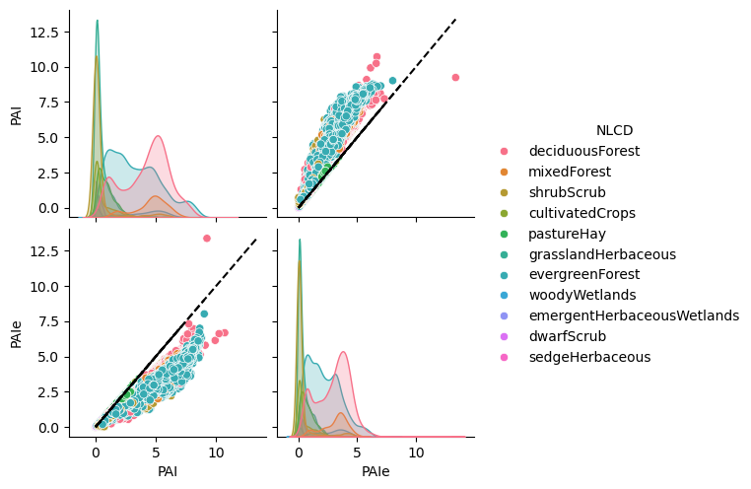
Figure 21. Effect of clumping on LAI (not figure is in terms of of PAI to isolate effect)
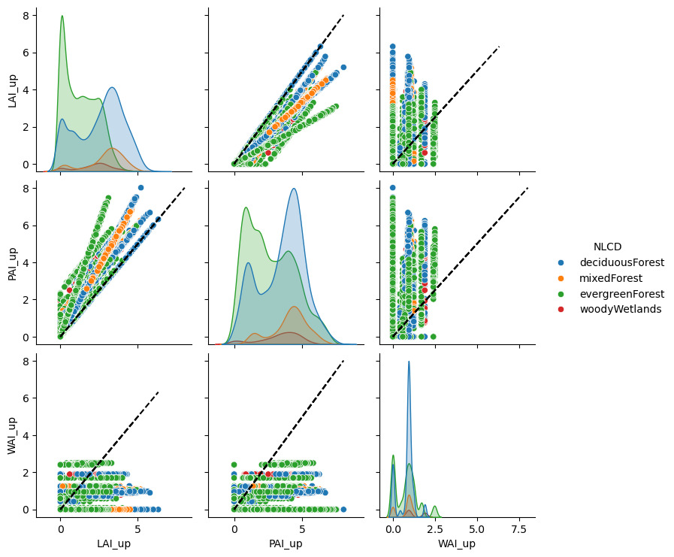
Figure 22. Effect of woody area on LAI.
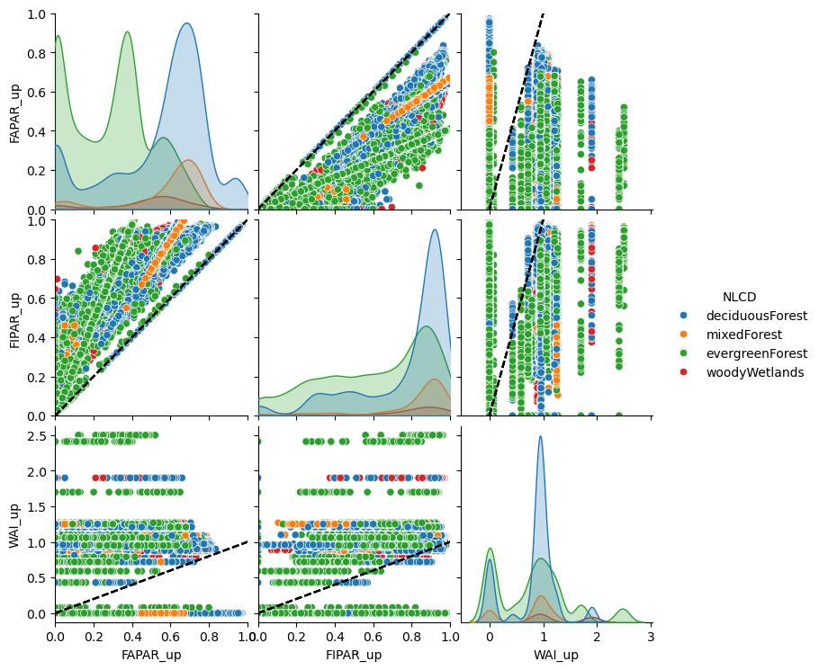
Figure 23 Effect of woody area on FAPAR.

